

***project title***

**Cause Of Death**

**Submitted by:-**

**Hritik yadav**

**Submitted to:-**

**Ms. Khushboo garh**

**Acknowledgement**

**I WOULD LIKE TO GAVE MY GRATITUDE TO ‘FLIP ROBO’ WHO GAVE THIS WONDERFULL OPPORTUNITY TO WORK ON THIS DATASET PROJECT ASLO HEARTFUL THANK TO ‘KHUSHBOO MAM’ TO CLEAR MY CONFUSIONS AND DOUBTS.**

* **THE SKILLS WHICH USE TO COMPLETE THE PROJECT:-**

1. **DATA VISULIZATION**
2. **MATPLOTLIB, SEABORN**
3. **PANDAS LIBRARY**
4. **NUMPY LIBRARY**
5. **EDA KNOWLEDGE**

***INTRODUCTION***

A straightforward way to assess the health status of a population is to focus on mortality – or concepts like child mortality or life expectancy, which are based on mortality estimates. A focus on mortality, however, does not take into account that the burden of diseases is not only that they kill people, but that they cause suffering to people who live with them. Assessing health outcomes by both mortality and morbidity (the prevalent diseases) provides a more encompassing view on health outcomes. This is the topic of this entry. The sum of mortality and morbidity is referred to as the ‘burden of disease’ and can be measured by a metric called ‘Disability Adjusted Life Years‘ (DALYs). DALYs are measuring lost health and are a standardized metric that allow for direct comparisons of disease burdens of different diseases across countries, between different populations, and over time. Conceptually, one DALY is the equivalent of losing one year in good health because of either premature death or disease or disability. One DALY represents one lost year of healthy life. The first ‘Global Burden of Disease’ (GBD) was GBD 1990 and the DALY metric was prominently featured in the World Bank’s 1993 World Development Report. Today it is published by both the researchers at the Institute of Health Metrics and Evaluation (IHME) and the ‘Disease Burden Unit’ at the World Health Organization (WHO), which was created in 1998. The IHME continues the work that was started in the early 1990s and publishes the Global Burden of Disease study.

***Content:-***

In this Data-set, we have Historical Data of different cause of deaths for all ages around the World. The key features of this Data-set are: Meningitis, Alzheimer's Disease and Other Dementia's, Parkinson's Disease, Nutritional Deficiencies, Malaria, Drowning, Interpersonal Violence, Maternal Disorders, HIV/AIDS, Drug Use Disorders, Tuberculosis, Cardiovascular Diseases, Lower Respiratory Infections, Neonatal Disorders, Alcohol Use Disorders, Self-harm, Exposure to Forces of Nature, Diarrhea Diseases, Environmental Heat and Cold Exposure, Neoplasms, Conflict and Terrorism, Diabetes Mellitus, Chronic Kidney Disease, Poisonings, Protein-Energy Malnutrition, Road Injuries, Chronic Respiratory Diseases, Cirrhosis and Other Chronic Liver Diseases, Digestive Diseases, Fire, Heat, and Hot Substances, Acute Hepatitis.

***Data-set Glossary (Column-wise)***

01. Country/Territory - Name of the Country/Territory

02. Code - Country/Territory Code

03. Year - Year of the Incident

04. Meningitis - No. of People died from Meningitis

05. Alzheimer's Disease and Other Dementia s - No. of People died from Alzheimer's Disease and Other Dementia's

06. Parkinson's Disease - No. of People died from Parkinson's Disease

07. Nutritional Deficiencies - No. of People died from Nutritional Deficiencies

08. Malaria - No. of People died from Malaria

09. Drowning - No. of People died from Drowning

10. Interpersonal Violence - No. of People died from Interpersonal Violence

11. Maternal Disorders - No. of People died from Maternal Disorders

12. Drug Use Disorders - No. of People died from Drug Use Disorders

13. Tuberculosis - No. of People died from Tuberculosis

14. Cardiovascular Diseases - No. of People died from Cardiovascular Diseases

15. Lower Respiratory Infections - No. of People died from Lower Respiratory Infections

16. Neonatal Disorders - No. of People died from Neonatal Disorders

17. Alcohol Use Disorders - No. of People died from Alcohol Use Disorders

18. Self-harm - No. of People died from Self-harm

19. Exposure to Forces of Nature - No. of People died from Exposure to Forces of Nature

20. Diarrheal Diseases - No. of People died from Diarrhea Diseases

21. Environmental Heat and Cold Exposure - No. of People died from Environmental Heat and Cold Exposure

22. Neoplasms - No. of People died from Neoplasms

23. Conflict and Terrorism - No. of People died from Conflict and Terrorism

24. Diabetes Mellitus - No. of People died from Diabetes Mellitus

25. Chronic Kidney Disease - No. of People died from Chronic Kidney Disease

26. Poisonings - No. of People died from Poisoning

27. Protein-Energy Malnutrition - No. of People died from Protein-Energy Malnutrition

28. Chronic Respiratory Diseases - No. of People died from Chronic Respiratory Diseases

29. Cirrhosis and Other Chronic Liver Diseases - No. of People died from Cirrhosis and Other Chronic Liver Diseases

30. Digestive Diseases - No. of People died from Digestive Diseases

31. Fire, Heat, and Hot Substances - No. of People died from Fire or Heat or any Hot Substances

32. Acute Hepatitis - No. of People died from Acute Hepatitis

**ANALYTICAL PORTION**

1. **CONNECTED WITH DATAFRAME:-**

* **THE DATA SET IS PROVIDED BY FLIPROBO IN CSV FORMAT**
* **THE CSV FILE CONTAIN 6120 ROWS AND 34 COLUMNS**
* **TO CONNECT CSV FILE USE PANDAS LIBRARY**
* **TEIR IS NO NULL VALUE IN THE DATAFRAME**
* **TEIR IS NO DUPLICATE VALUE IN THE DATAFRAME**



* **HEARTMAP OF NULL DATA**

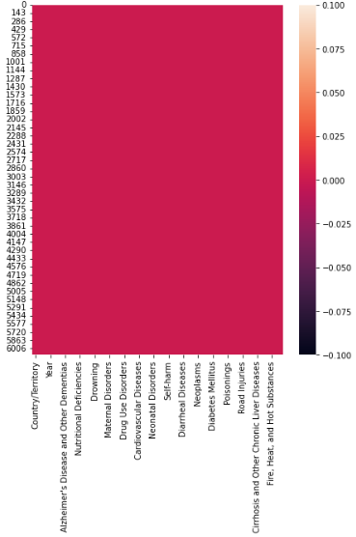

* **DATATYPE OF DATASET**

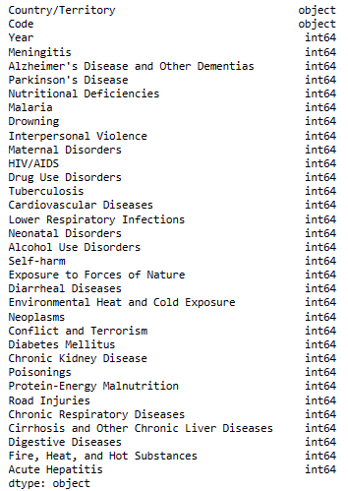

1. **HARDWARE AND SOFTWARE USED IN THE PROJECT:-**

* **Hardware Used:-**

**1. Processor — Intel i3 processor with 2. 4GHZ**

**3. RAM — 4 GB**

**4. GPU — 2GB AMD Radeon Graphics card**

* **Software utilised:-**

1. **Anaconda – Jupyter Notebook**

**Libraries Used –**

**2. Different libraries are used while building ML model and Visualization of data**

**3. LIBRARY USE IN PROJECT:-**

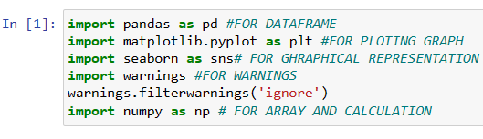

* **PANDAS FOR DATAFRAME**
* **NUMPY FOR BASIC**
* **MATPLOTLIP.PYPLOT FOR DATA VISUALIZATION**
* **SEABORN FOR PLOTING GRAPHS**
* **WARNINGS FOR FILTERING THE WARNINGS**

**4. IDENTIFICATION OF DATA ON THE BASIS OF DIFFERENT CATEGORIES**

* **There is lot of data present in data-set, so we have to find data on different-different ways**

# **PEOPLE DIED IN AFGANISTHAN FROM(1990 to 2019)**

# **EXAMINE IN AFGANISTHAN 2019 PEOPLE DIED FROM WHICH DISEASE**

# **LETS EXAMINE DEATH IN INDIA FROM 2007 TO 2019 BY DISEASES**

# **LETS EXAMIN THE DEATH IN CHINA FROM 2007 TO 2019**

# **LETS EXAMIN THE DEATH FROM THE DISEASES IN UNITED STATE**

# **make data-frame of death from different diseases in INDIA,CHINA and UNITED STATE**

# **lets examine death in India, USA and china from 1990 to 2019**

5. START EXPLORATORY DATA ANALYSIS:-

# **PEOPLE DIED IN AFGANISTHAN FROM(1990 to 2019)**

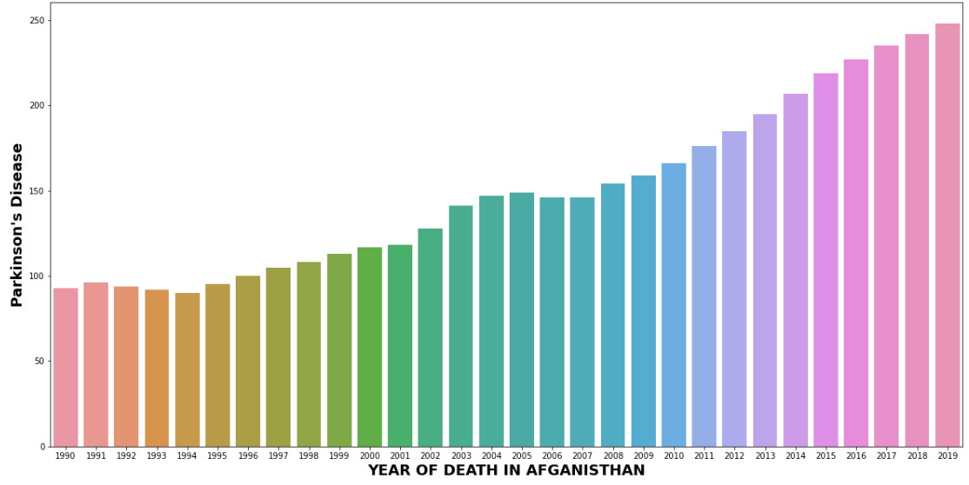

OBSERVATION:-

***\* AS WE SHOW THE GRAPH IS CONTINOUSLY***

***INCREASING YEAR BY YEAR***

***\* IN 2019 MAXIMUM PEOPLE DIED IN***

***AFGANISTHAN***

# **EXAMINE IN AFGANISTHAN 2019 PEOPLE DIED FROM WHICH DISEASE**

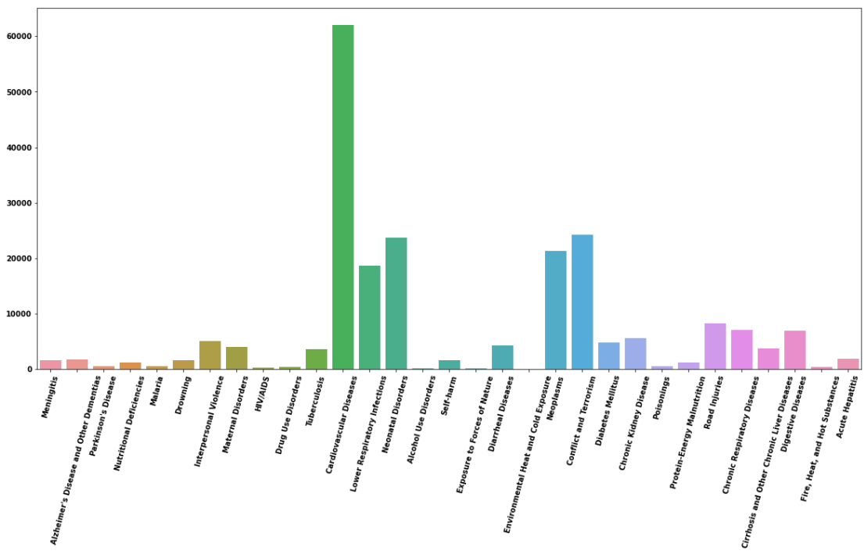

OBSERVATION:-

***\* IN 2019 IN AFGANISTHAN MOSTLY PEOPLE DIED BY***

***CARDLOVASCULAR***

***\* ALOMOST 6000 PEOPLE DIED BY CARDLOVASCULAR***

***\* THEN NEONATAL DISORDERS AND LOWER***

***RESPIRATORY INFECTION***

# **LETS EXAMINE DEATH IN INDIA FROM 2007 TO 2019 BY DISEASES:-**

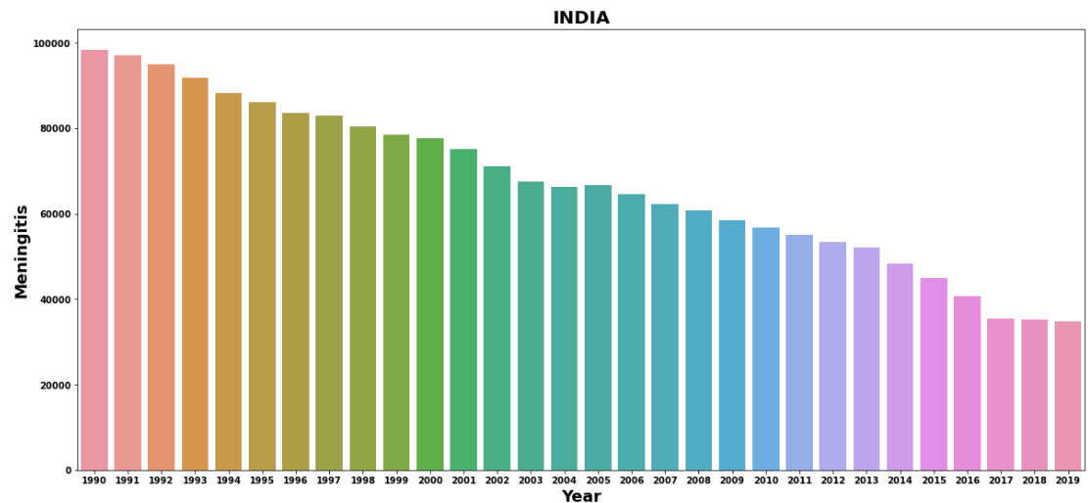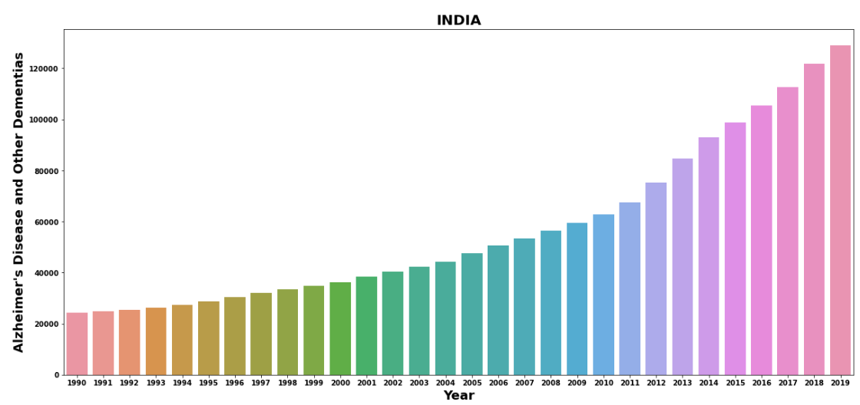

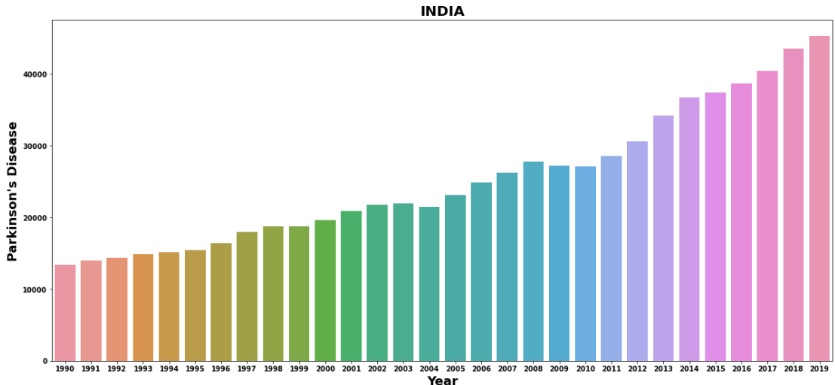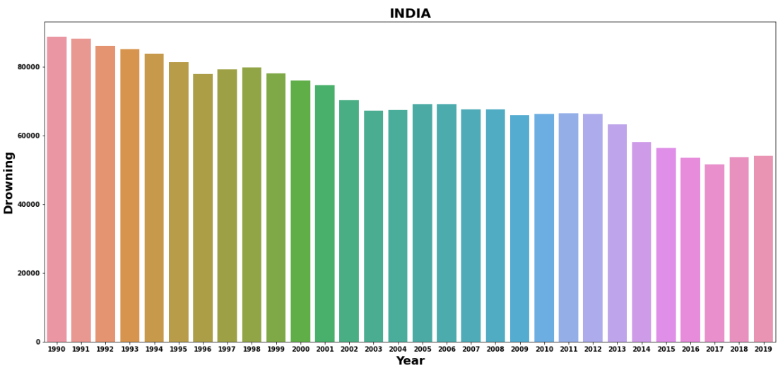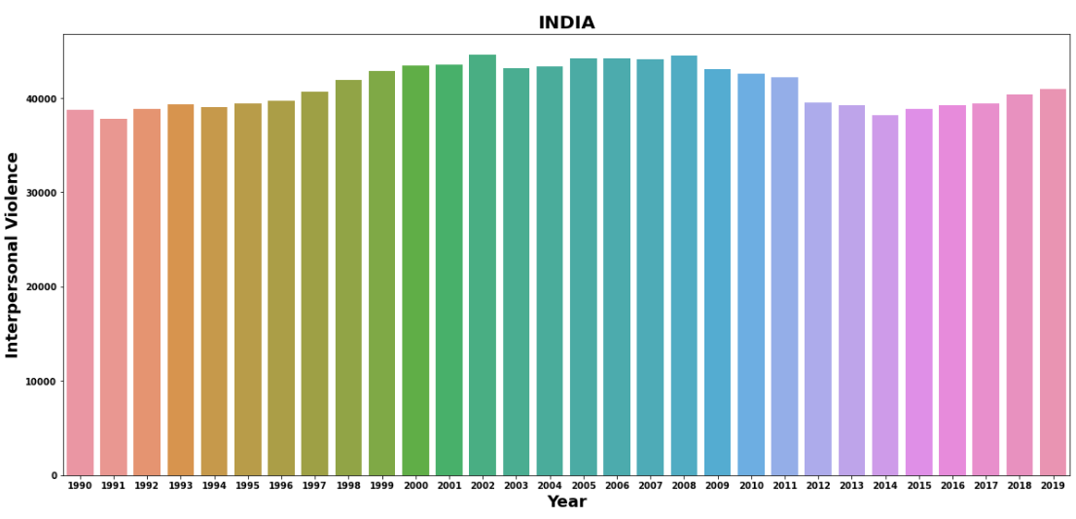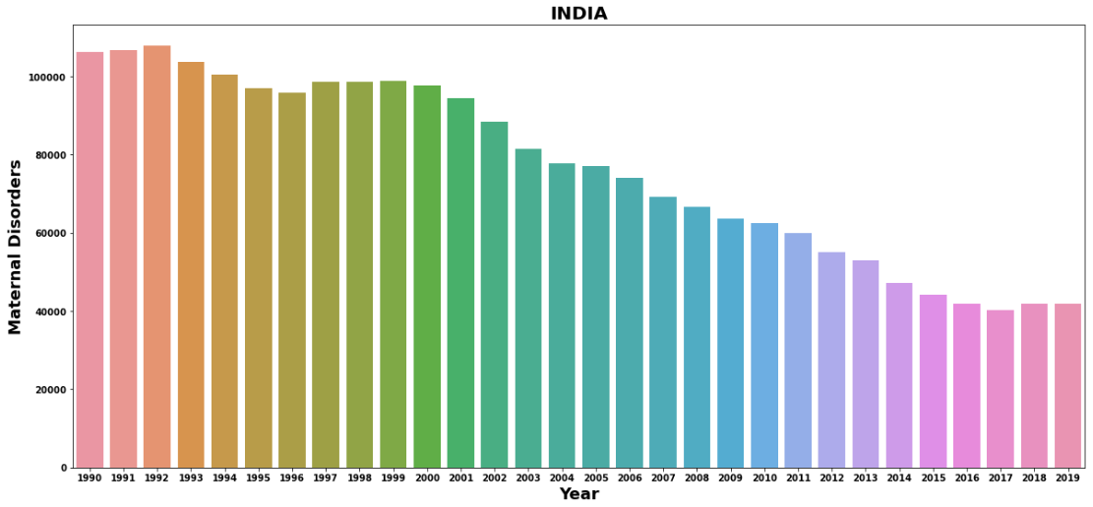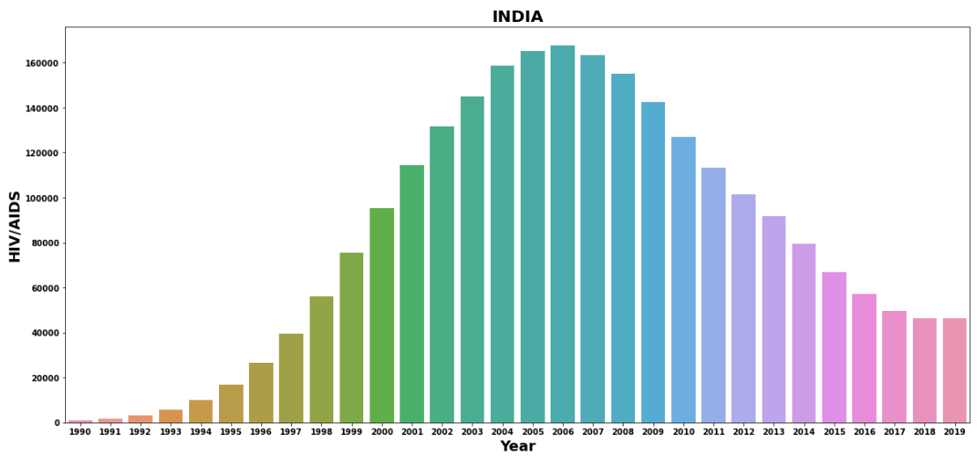

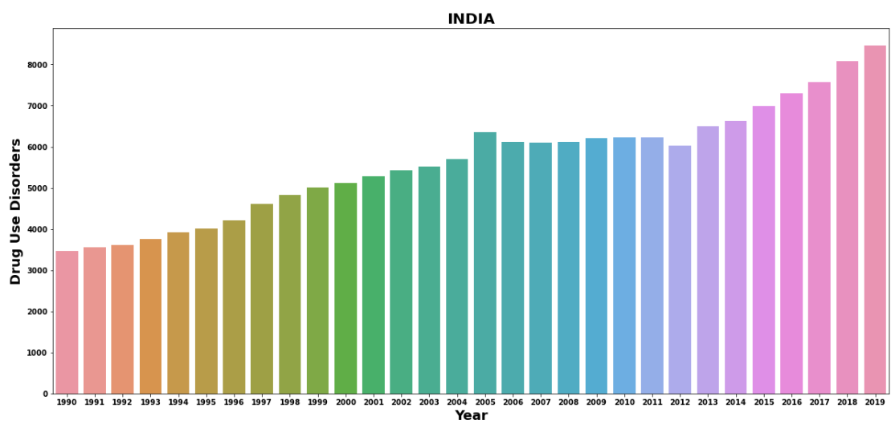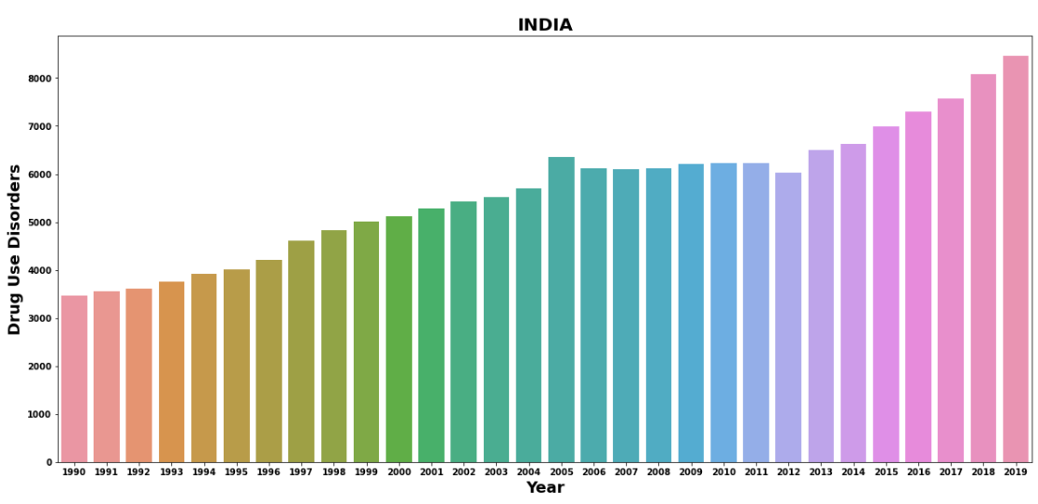

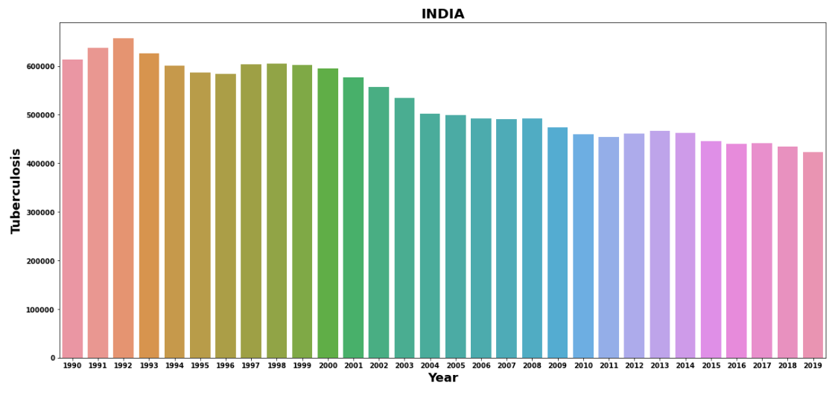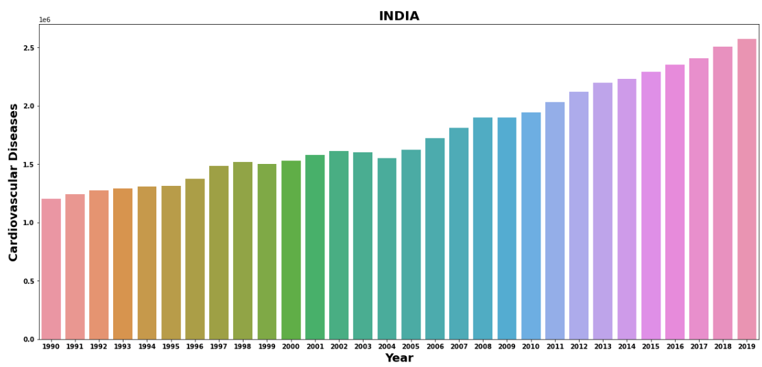

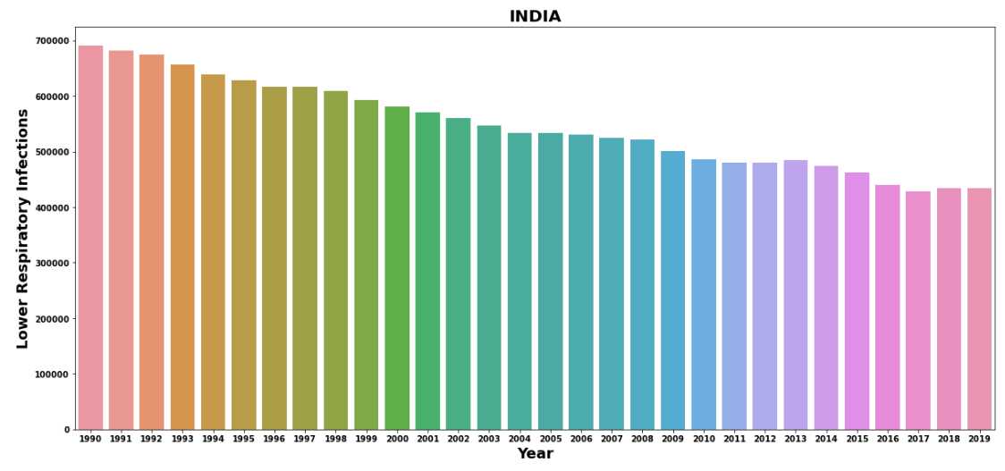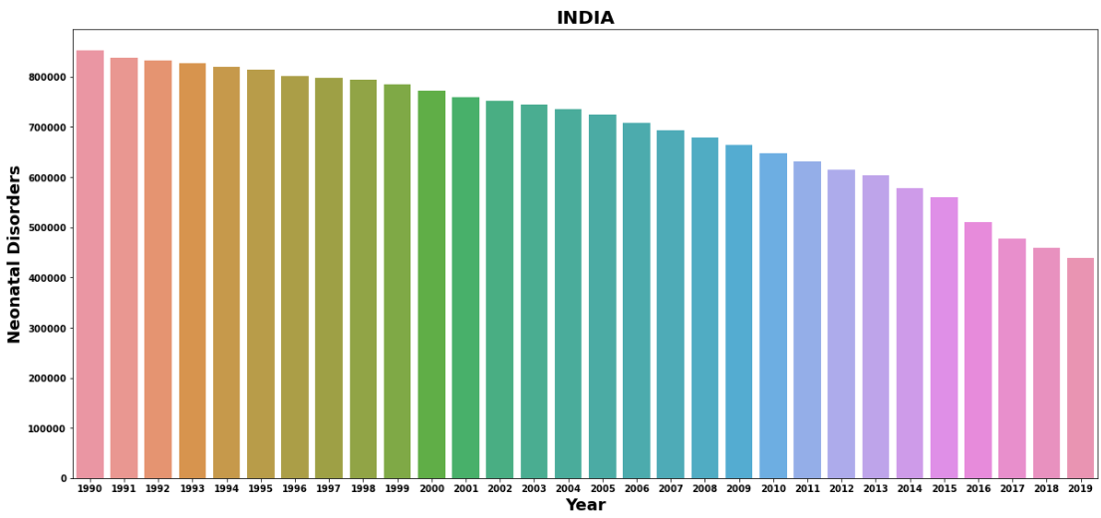

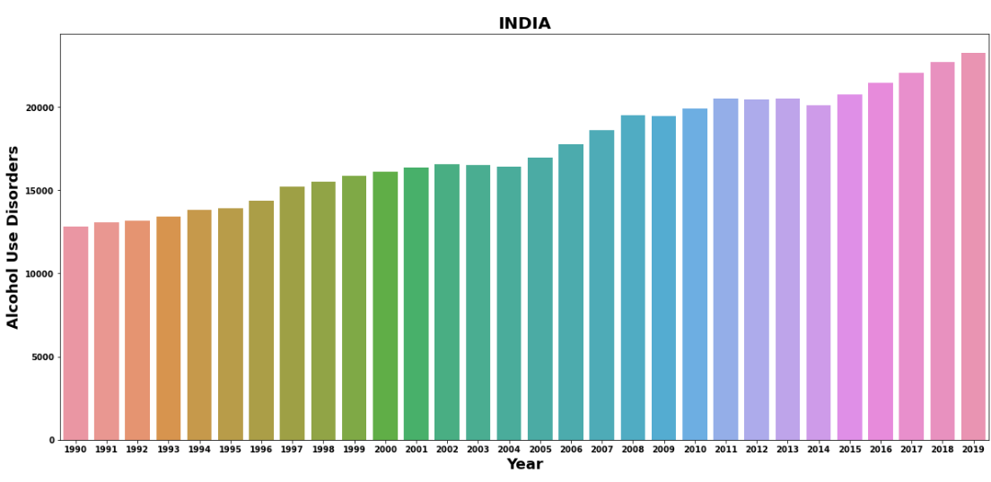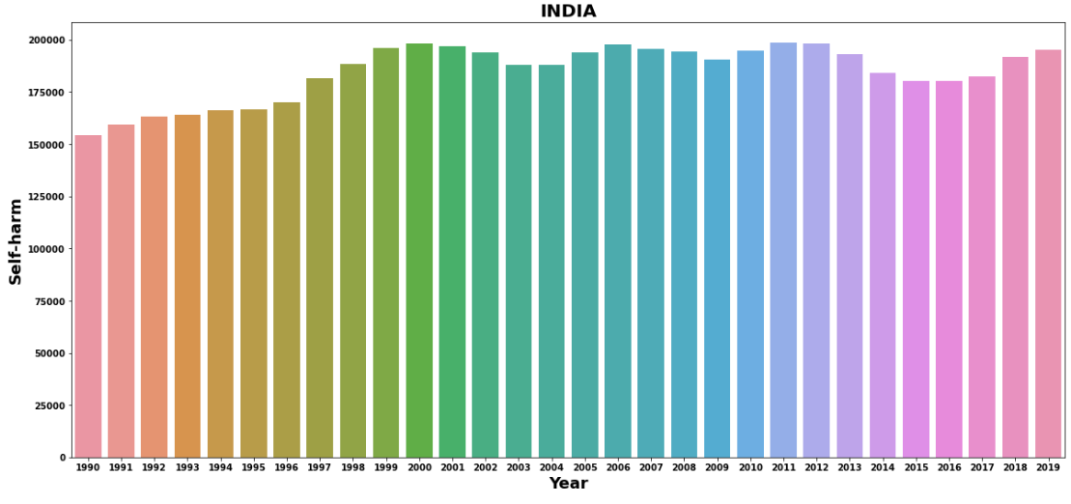

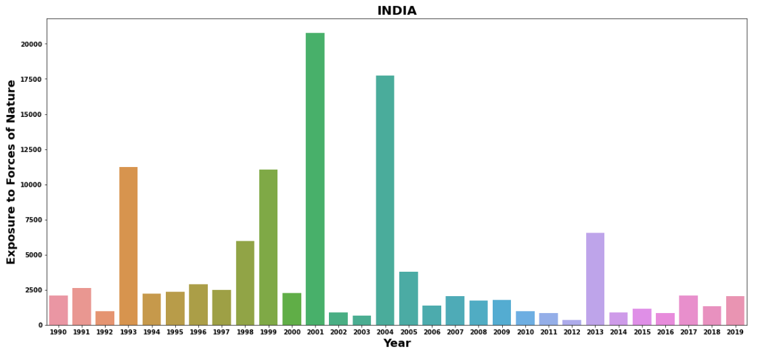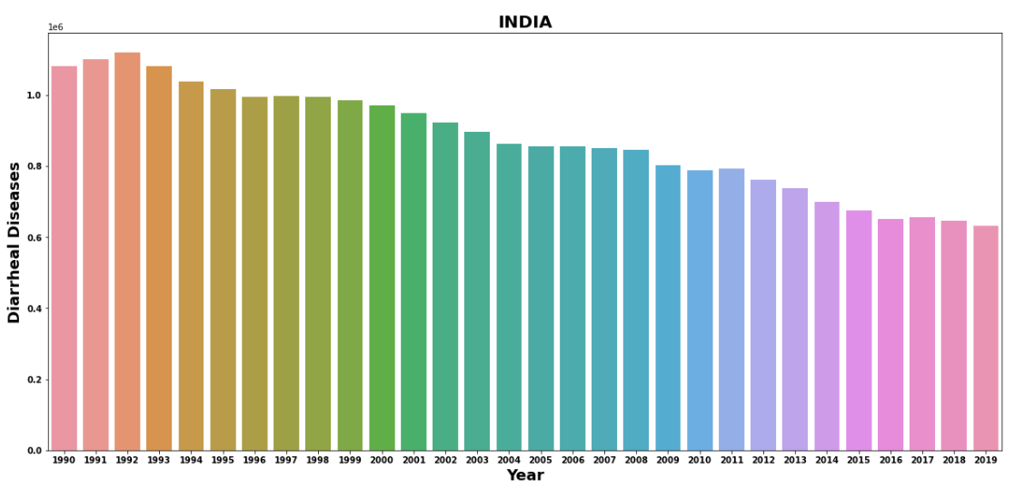

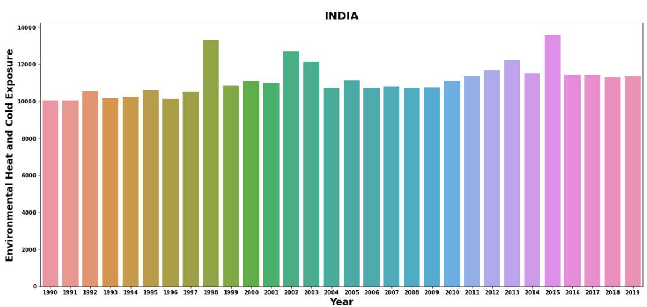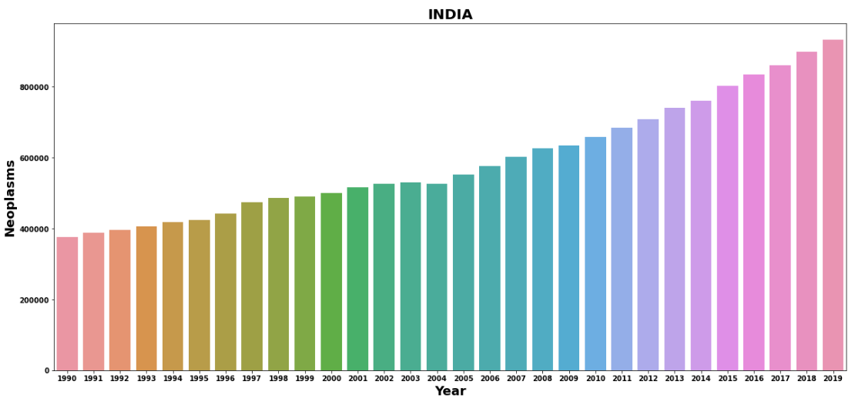

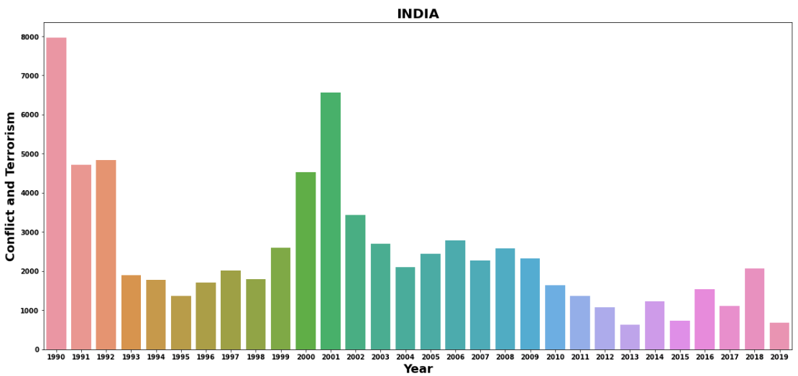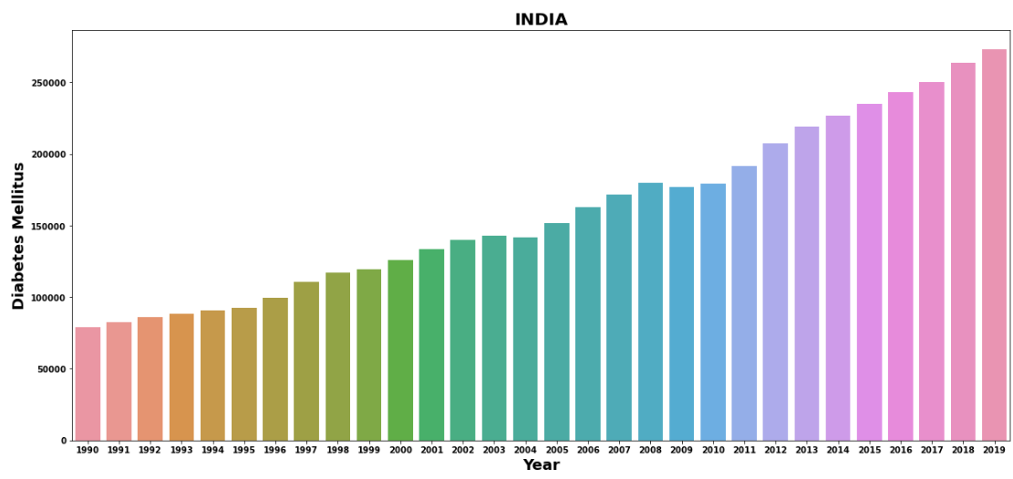

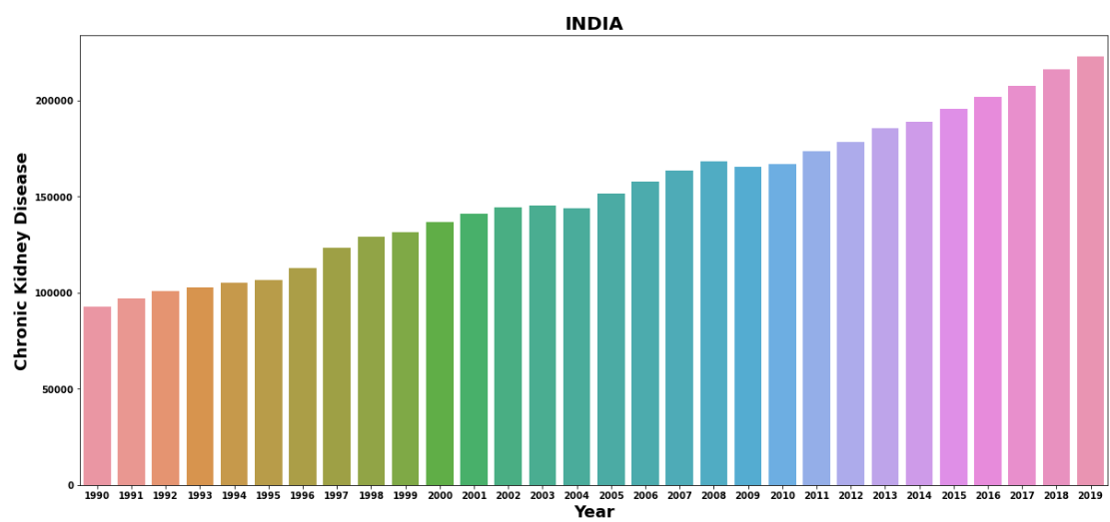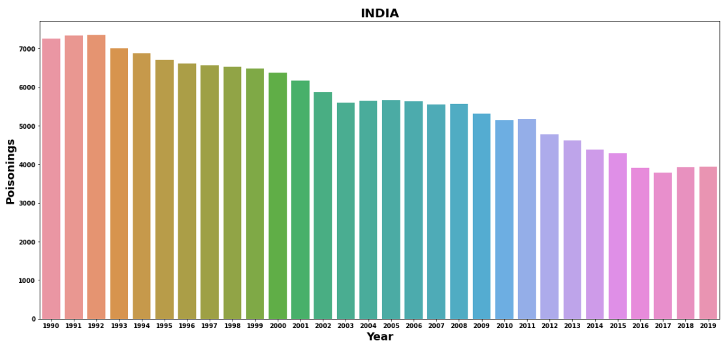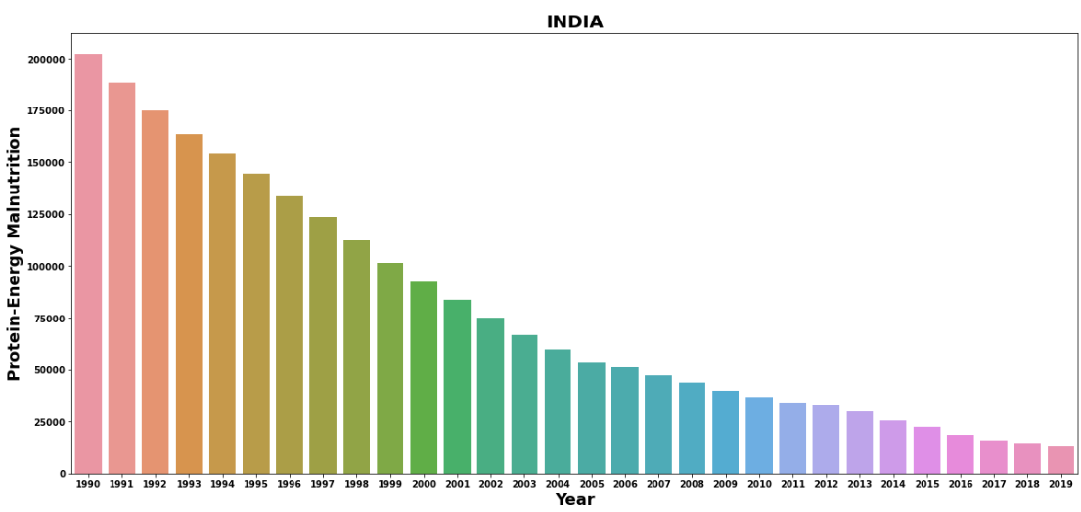

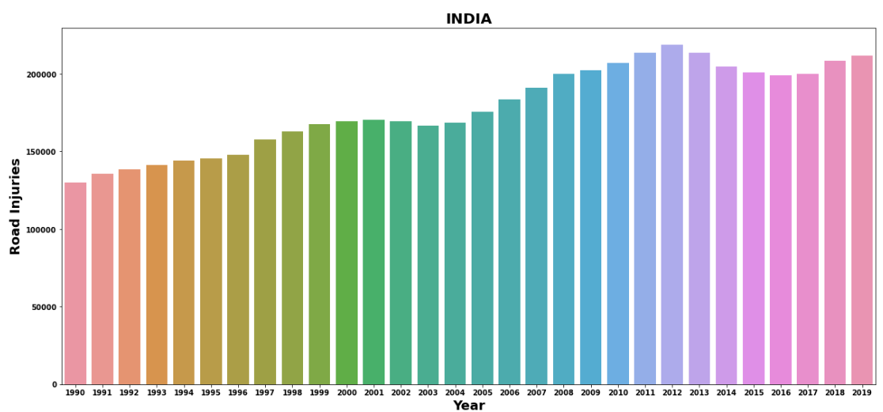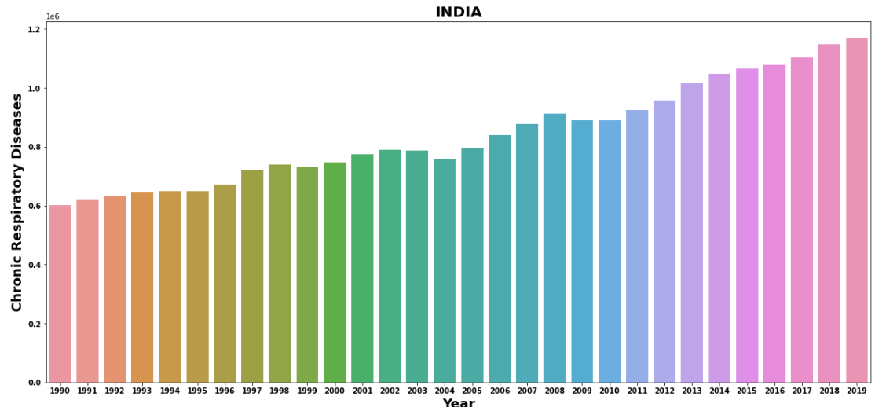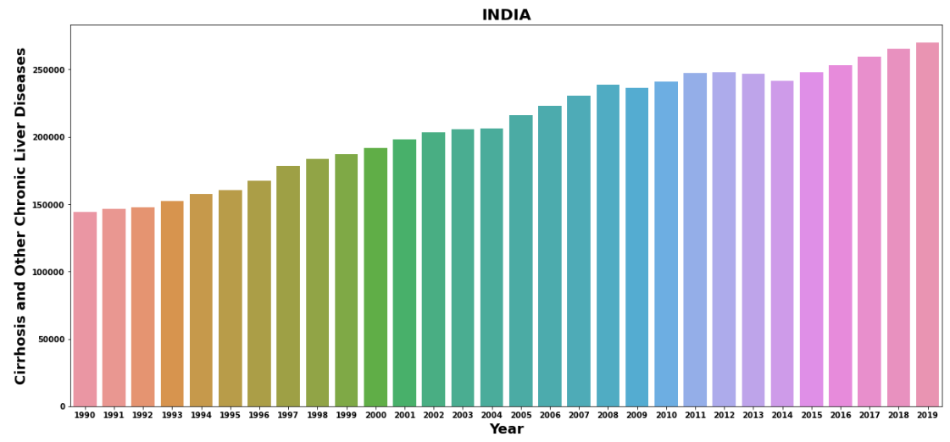

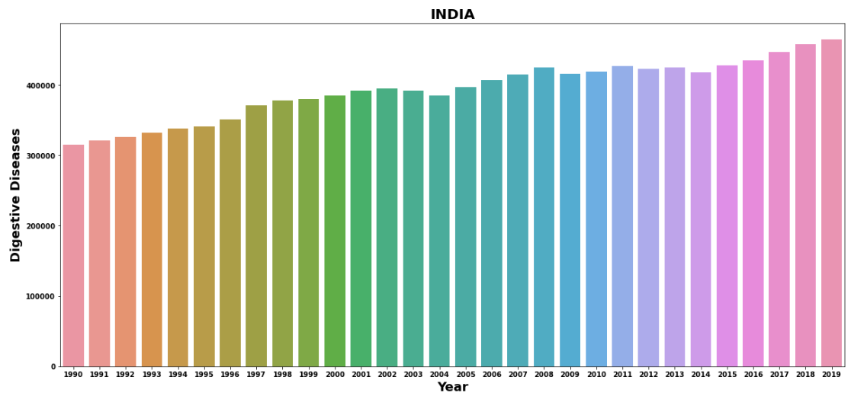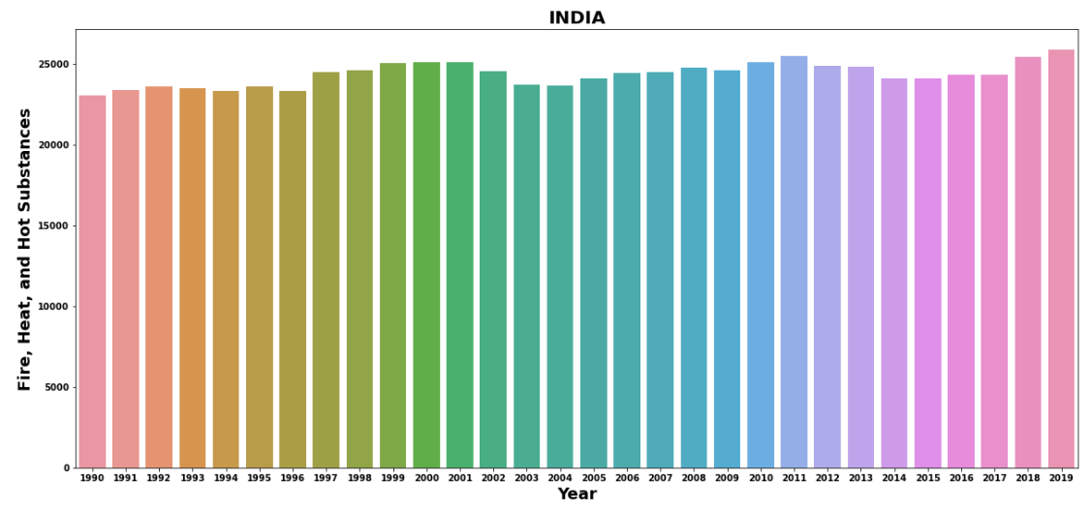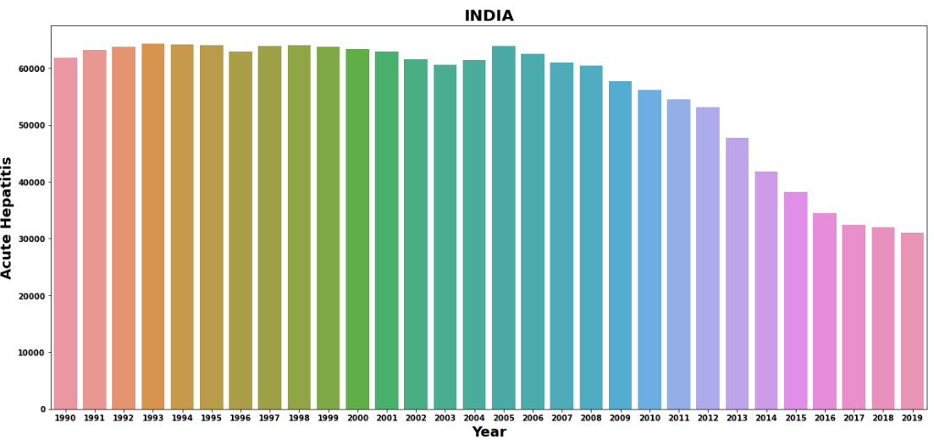

OBSERVATION:-

***\* IN INDIA DEATH FROM THE MENINGITIS***

***SIGHTLY DECREASE YEAR BY YEAR***

***\* THE DEATH FORM THE ALZHEIMER'S DISESSE ARE INCREASES YEAR BY YEAR***

***\* THE DEATH FROM THE PARKINSON'S DISEASES INCREASES YEAR BY YEAR***

***\* THE DEATH FROM THE NUTRITIONAL***

***DEFICIENCIES IS DECREASES YEAR BY YEAR***

***\* THE DEATH FROM THE MALARIA DECREASES YEAR BY YEAR***

***\* THE DEATH FROM THE DROWNING DECREASES VERY SLOWLY YEAR BY YEAR***

***\* THE DEATH FROM INTERPERSONAL VIOLENCE SHOW NOT MUCH CHANGE***

***\* THE DEATH FROM MATERNAL DISORDERS***

***DECREASES YEAR BY YEAR***

***\* THE DEATH FROM HIV/AIDS HAS BEEN***

***RAPIDELY INCREASES IN 2004-2011 THEN***

***SLIGHTY DECREASES***

***\* THE DEATH FROM DRUG USE DISORDER IS***

***INCREASES YEAR BY YEAR***

***\* THE DEATH FROM TUBERCULOSIS IS***

***DECREASES YEAR BY YEAR***

***\* THE DEATH FROM CARDIOVASCULAR DISEASES INCREASES YEAR BY YEAR***

***\* THE DEATH FROM LOWER RESPIRATORY***

***INFECTION DECREASES VERY SLOWLY***

***\* THE DEATH FROM NEONATAL DISORDER***

***DECREASE YEAR BY YEAR***

***\* THE DEATH FROM ALCOHOL INCREASES YEAR BY YEAR***

***\* THE DEATH FROM SELF-HARM SIGHTLY***

***INCREASES YEAR BY YEAR***

***\* THE DEATH FROM EXPOSURE TO FORCES OF***

***NATURE INCREASE IN 1993 THEN 1999 THEN 2001 THEN 2004 THEN 2013***

***\* THE DEATH FROM Diarrhea Diseases is decreases year by year***

***\* THE DEATH FROM Environmental Heat and Cold Exposure SHOW NO INCREASE NO DECREASE***

***\* THE DEATH FROM Neoplasms IS INCREASES***

***YEAR BY YEAR***

***\* THE DEATH FROM Conflict and Terrorism IS***

***HIGHEST IN 1990 THEN IN 2001 AND 200***

***ALSO INCREASE THEN THE DEATH DECREASES***

***\* THE DEATH FROM THE Diabetes Mellitus***

***INCREASES YEAR BY YEAR***

***\* THE DEATH FORM THE Chronic Kidney Disease***

***INCREASES YEAR BY YEAR***

***\* THE DEATH FROM THE Poisonings DECREASES***

***YEAR BY YEAR***

***\* THE DEATH FROM THE Protein-Energy***

***Malnutrition DECREASES YEAR BY YEAR***

***\* THE DEATH FROM THE Road Injuries INCREASES YEAR BY YEAR***

***\* THE DEATH FROM THE Chronic Respiratory***

***INCREASES YEAR BY YEAR***

***\* THE DEATH FROM THE Cirrhosis and Other***

***Chronic Liver Diseases INCREASES YEAR BY YEAR***

***\* THE DEATH FRM THE Digestive Diseases***

***INCREASES YEAR BY YEAR***

***\* THE DEATH FROM THE Fire, Heat, and Hot***

***Substances SHOW NO INCREASE NO DECREASE***

***\* THE DEATH FORM THE Acute Hepatitis SHOW***

***RAPID DOWN FROM 2012***

# **LETS EXAMIN THE DEATH IN CHINA FROM 2007 TO 2019:-**

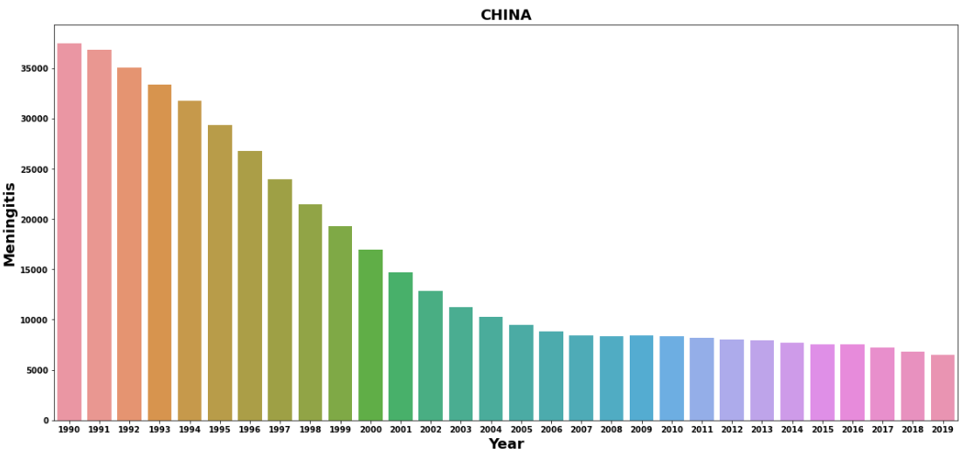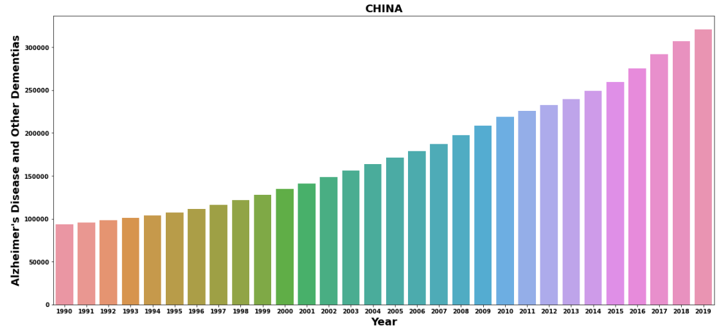

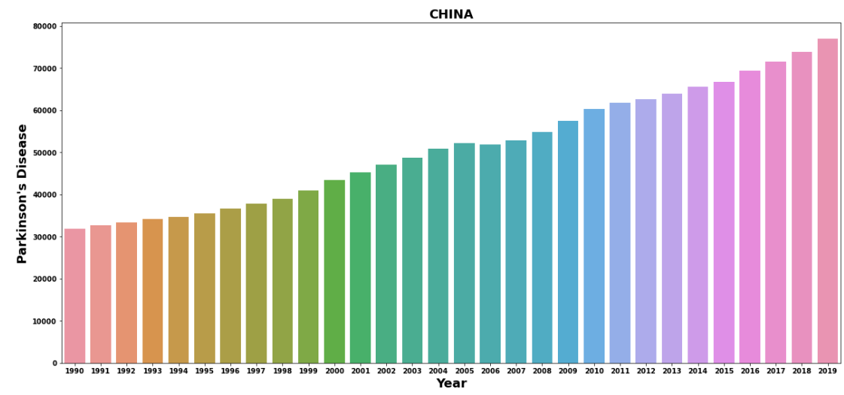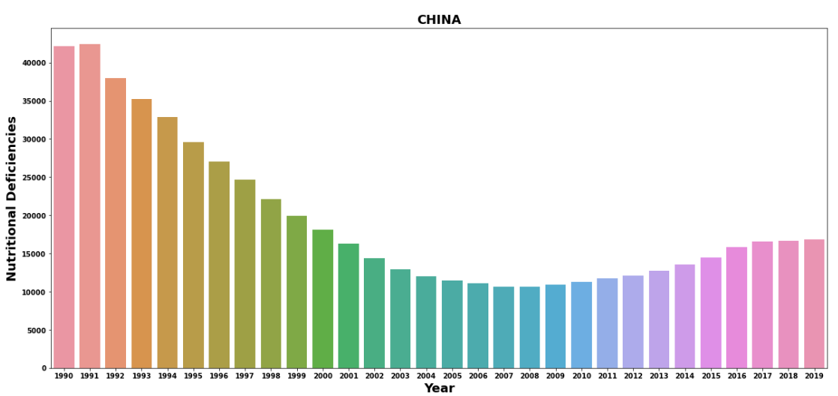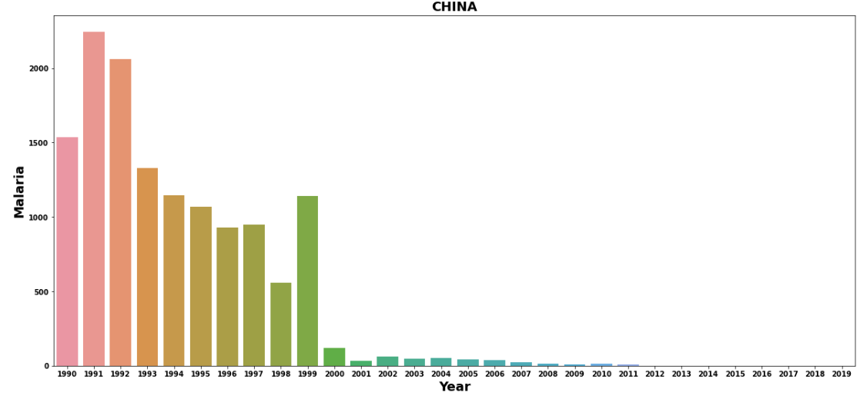

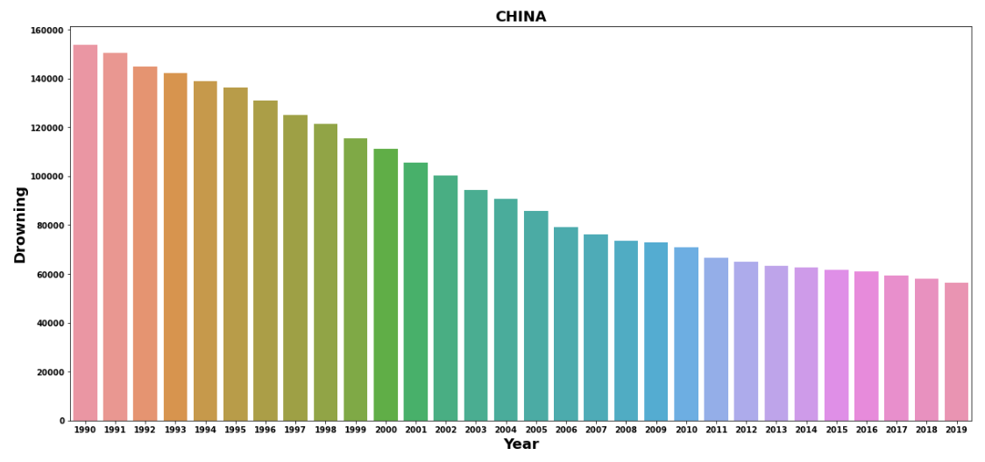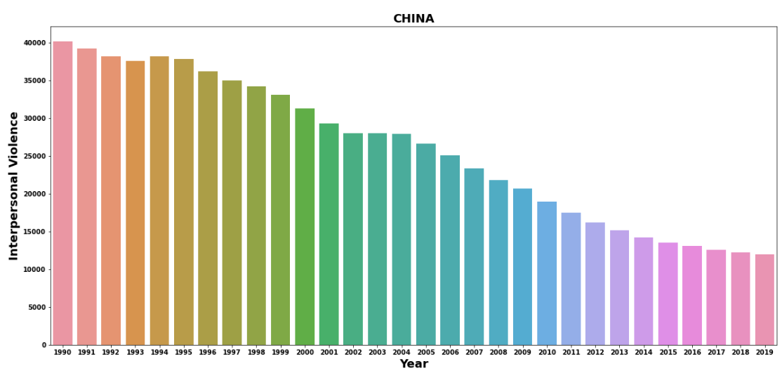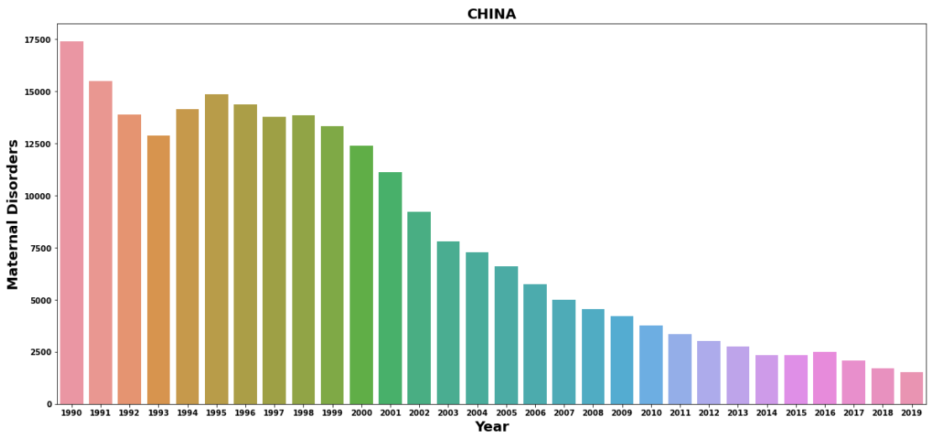

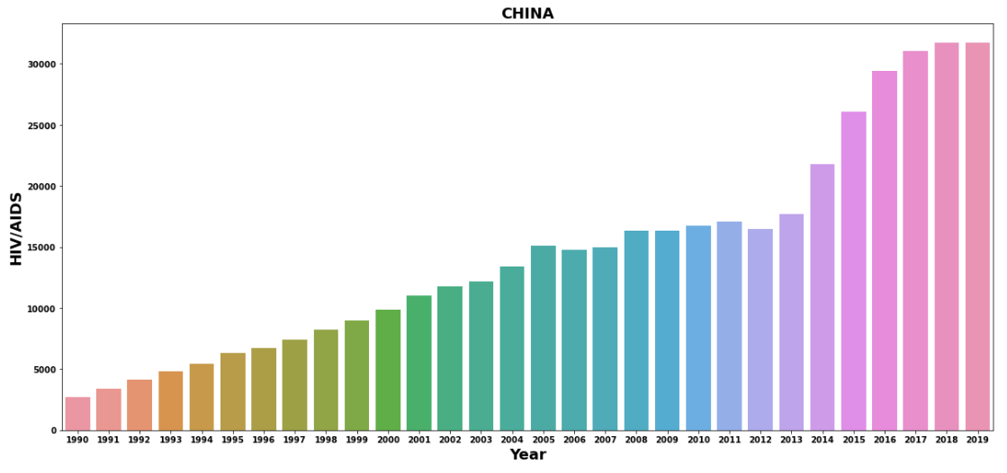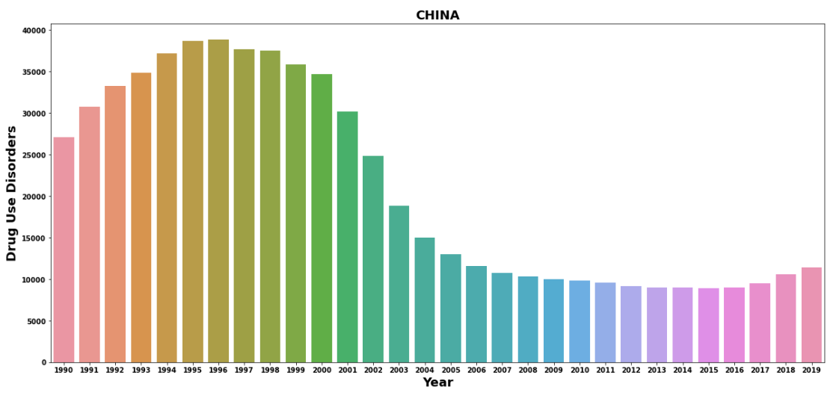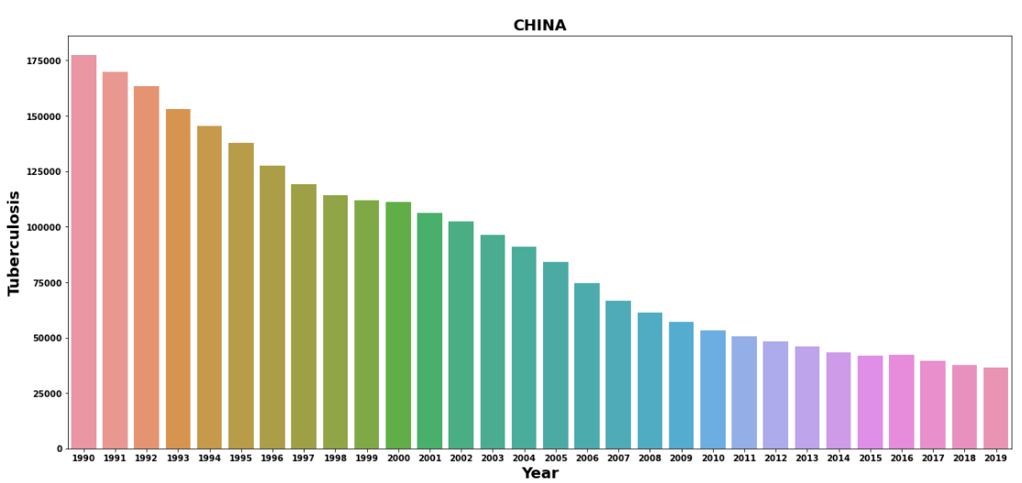

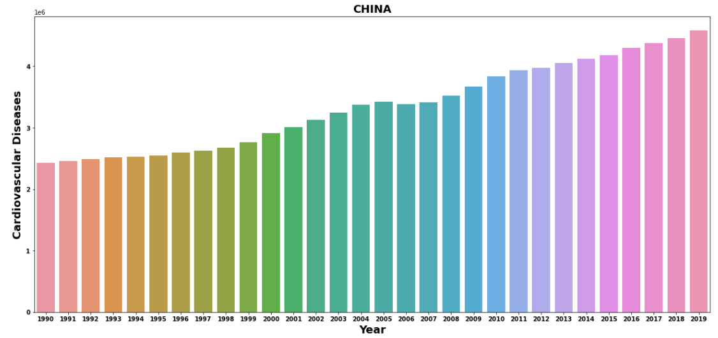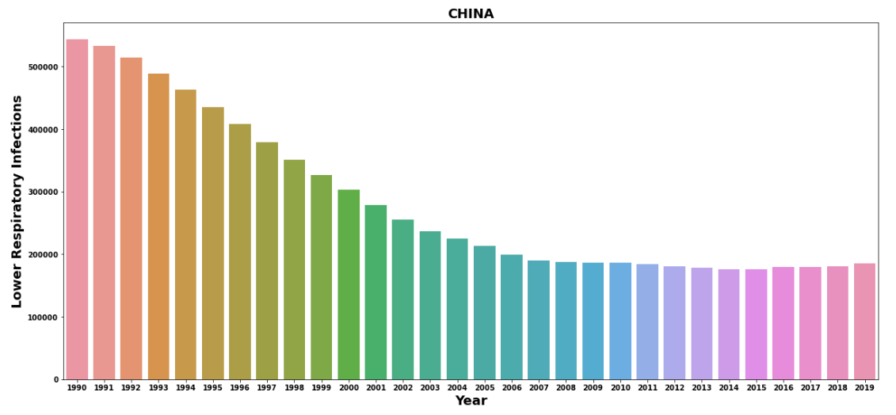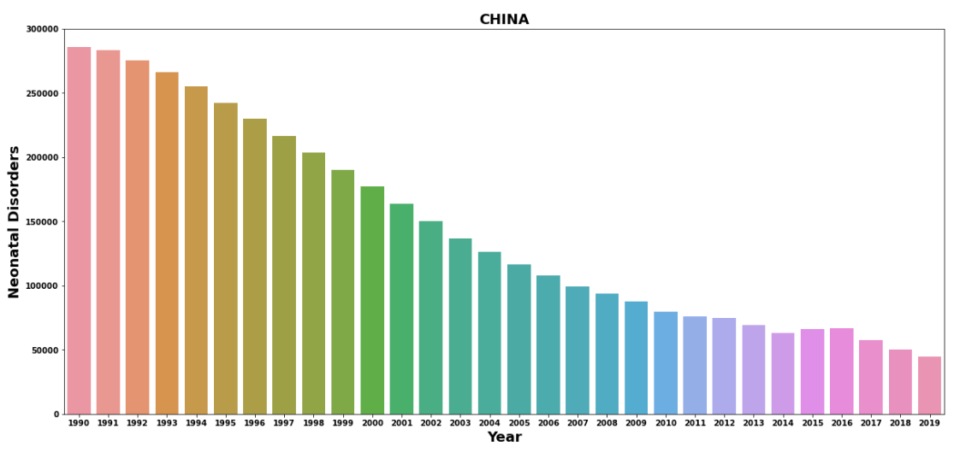

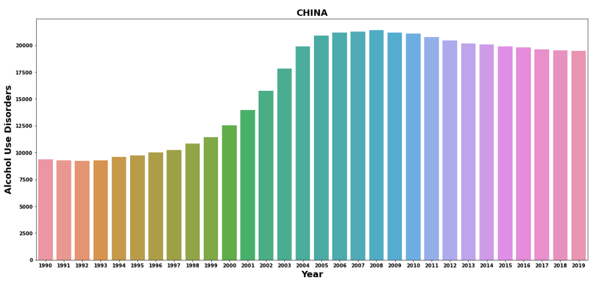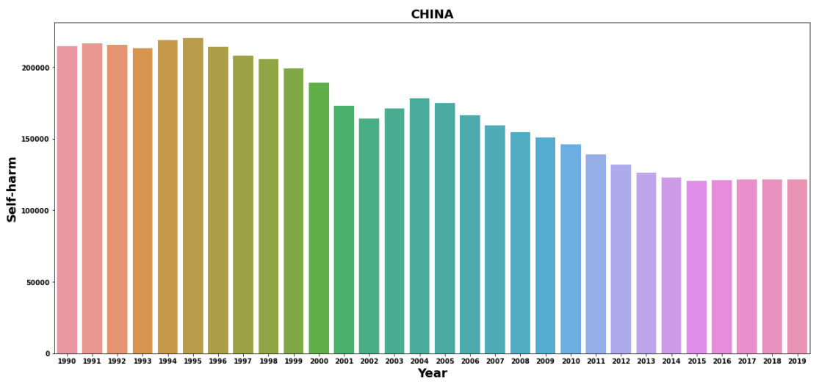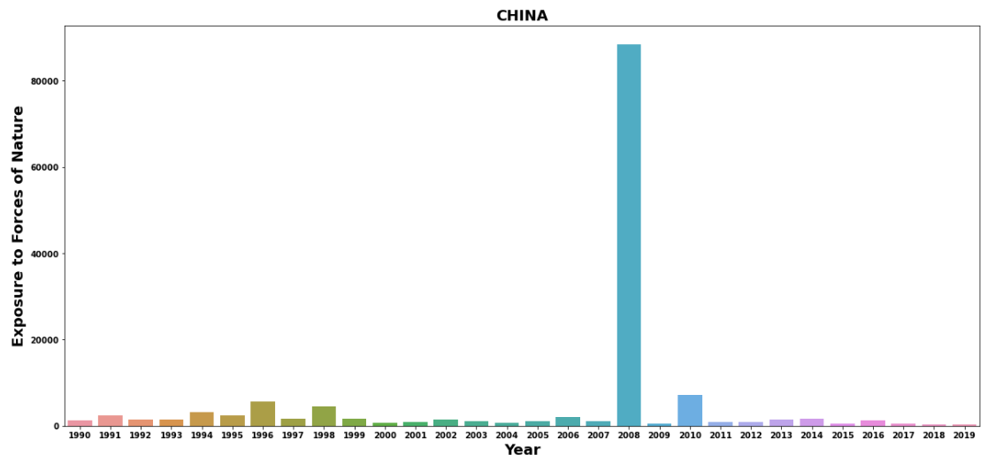

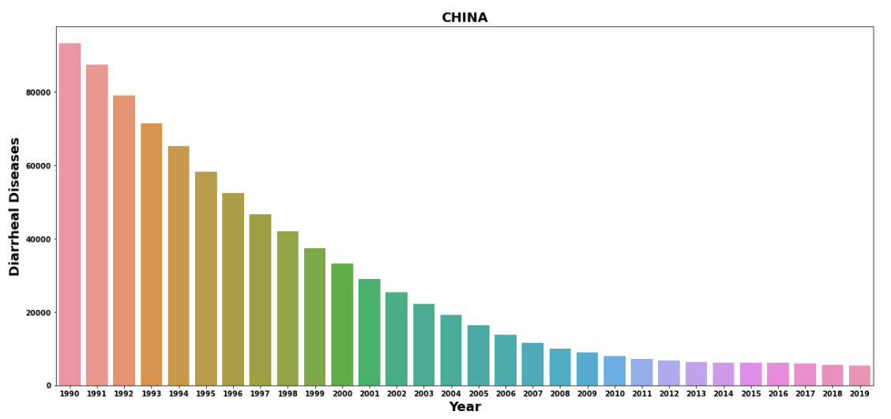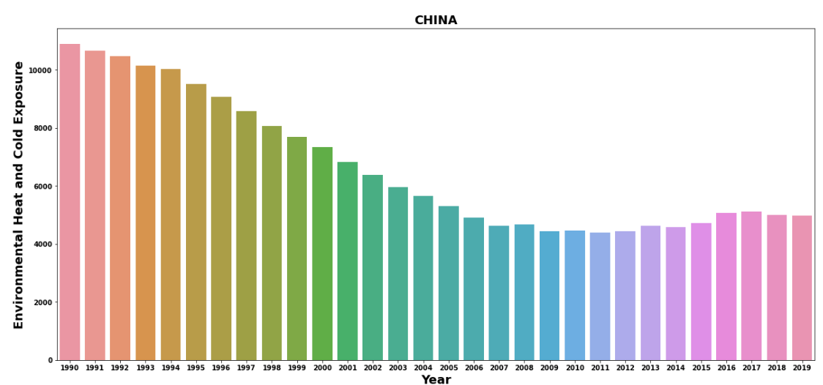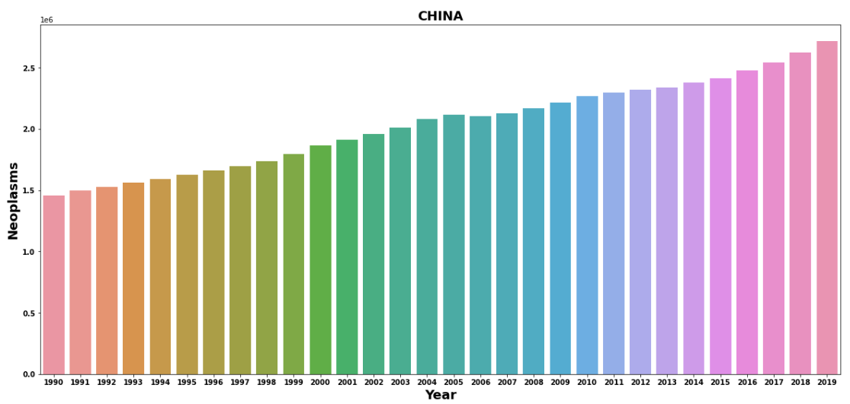

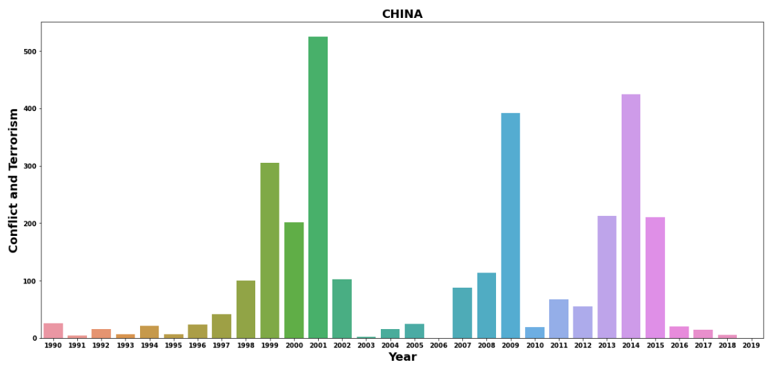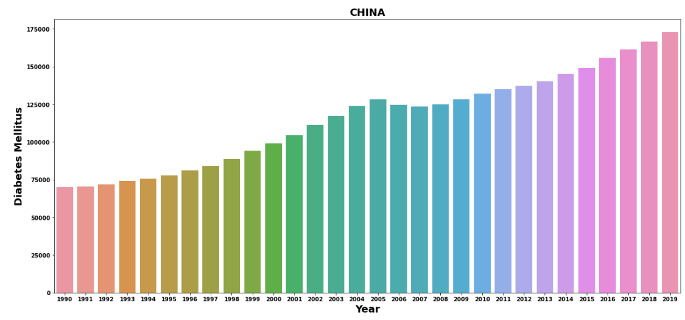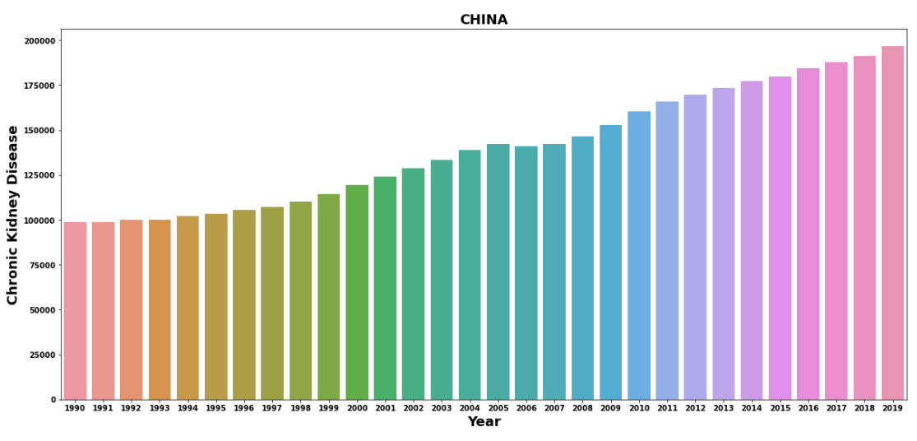

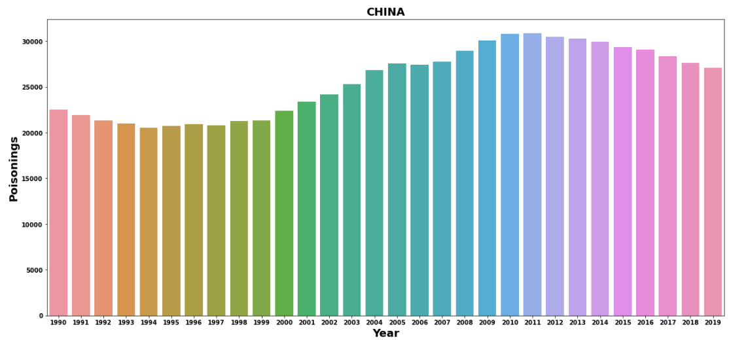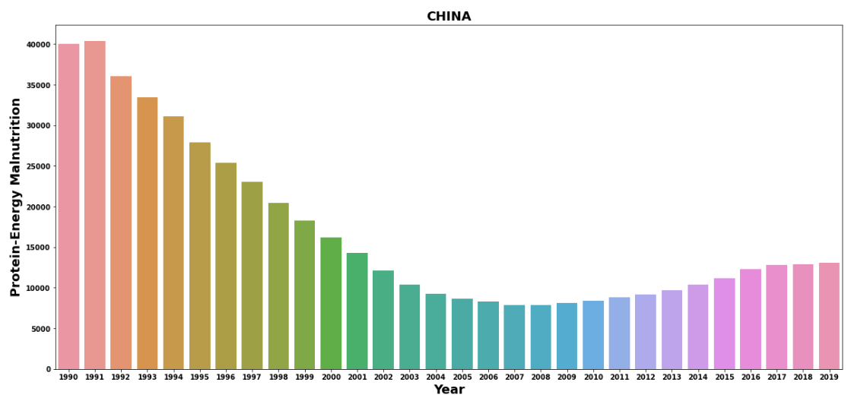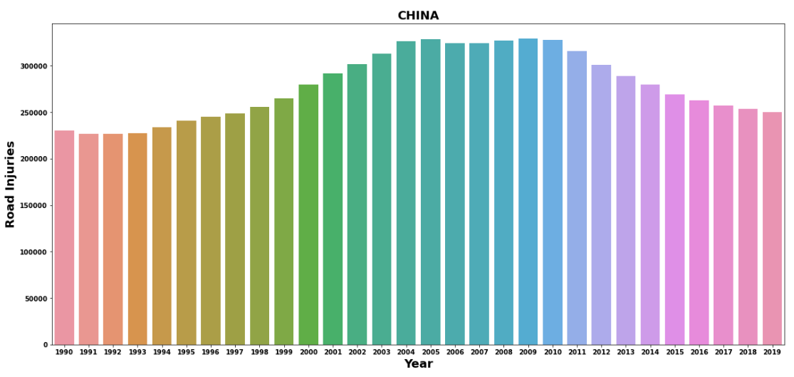

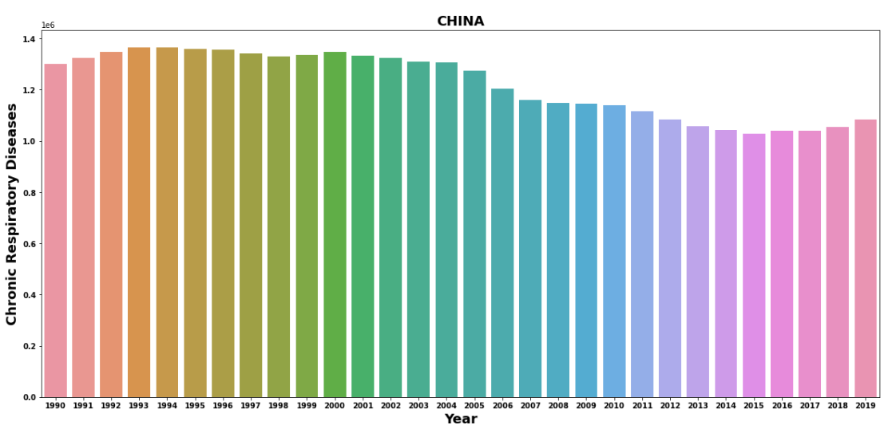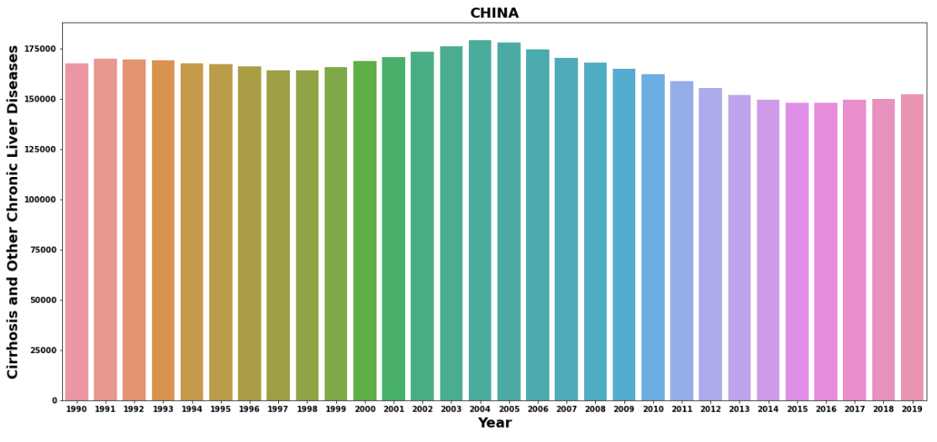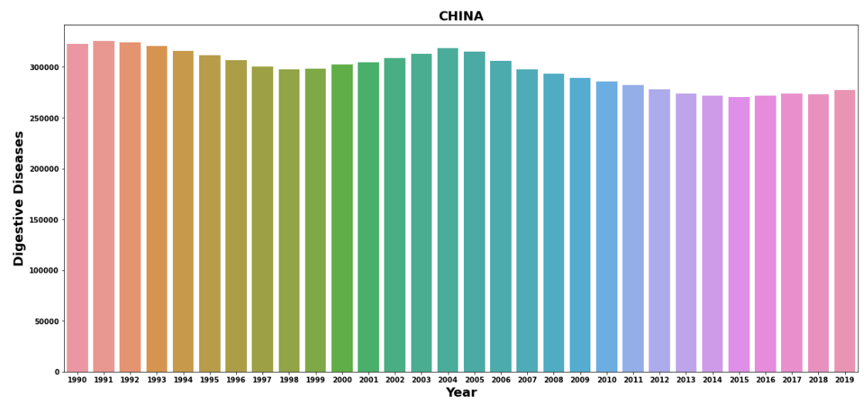

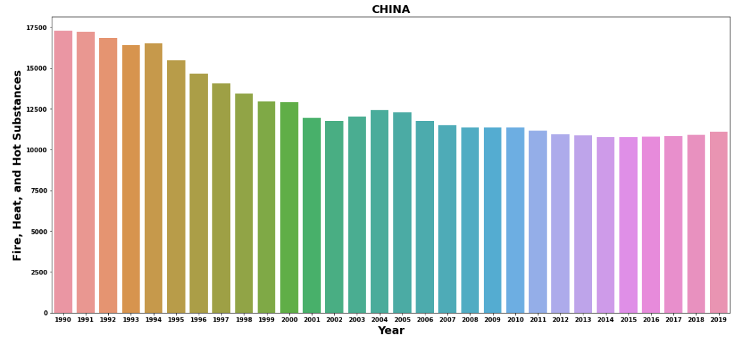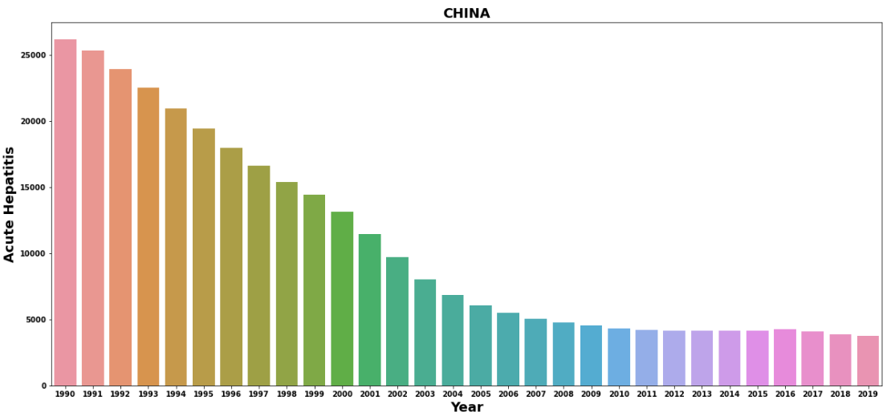**OBSERVATION:-**

* IN CHINA DEATH FROM THE MENINGITIS

SIGHTLY DECREASE YEAR BY YEAR

* THE DEATH FORM THE ALZHEIMER'S DISESSE ARE INCREASES YEAR BY YEAR

* THE DEATH FROM THE PARKINSON'S DISEASES INCREASES YEAR BY YEAR BUT SHOW SOME

INCREASE IN 2009

* THE DEATH FROM THE NUTRITIONAL

DEFICIENCIES IS DECREASES YEAR BY YEAR

* THE DEATH FROM THE MALARIA DECREASES

YEAR BY YEAR AND FROM 2011 MALARIA

SHOW ZERO DEATH

* THE DEATH FROM THE DROWNING DECREASES VERY SLOWLY YEAR BY YEAR

* THE DEATH FROM INTERPERSONAL VIOLENCE DECREASES YEAR BY YEAR

* THE DEATH FROM MATERNAL DISORDERS

DECREASES YEAR BY YEAR

* THE DEATH FROM HIV/AIDS HAS BEEN

RAPIDELY INCREASES IN 2013-2011 THEN

SLIGHTY DECREASES

* THE DEATH FROM DRUG USE DISORDER IS

DECRESES YEAR BY YEAR BUT SHOW

CONSTANT IN 2006 TO 2018

* THE DEATH FROM TUBERCULOSIS IS

DECREASES YEAR BY YEAR

* THE DEATH FROM CARDIOVASCULAR DISEASES INCREASES YEAR BY YEAR

* THE DEATH FROM LOWER RESPIRATORY

INFECTION DECREASES VERY SLOWLY

* THE DEATH FROM NEONATAL DISORDER

DECREASE YEAR BY YEAR

* THE DEATH FROM ALCOHOL INCREASES YEAR BY YEAR

* THE DEATH FROM SELF-HARM SIGHTLY

DECREASES YEAR BY YEAR

* THE DEATH FROM EXPOSURE TO FORCES OF

NATURE INCREASE IN 2008 THEN 2010

* THE DEATH FROM Diarrhea Diseases is decreases year by year

* THE DEATH FROM Environmental Heat and Cold Exposure DECREASE YEAR BY YEAR

* THE DEATH FROM Neoplasms IS INCREASES

YEAR BY YEAR

* THE DEATH FROM Conflict and Terrorism IS

HIGHEST IN 1999 THEN IN 2000 AND 2001,

2003 TO 2005 ALSO INCREASE THEN THE DEATH DECREASES

* THE DEATH FROM THE Diabetes Mellitus

INCREASES YEAR BY YEAR

* THE DEATH FORM THE Chronic Kidney Disease

INCREASES YEAR BY YEAR

* THE DEATH FROM THE Poisonings INCREASES

YEAR BY YEAR

* THE DEATH FROM THE Protein-Energy

Malnutrition DECREASES YEAR BY YEAR

* THE DEATH FROM THE Road Injuries INCREASES YEAR BY YEAR

* THE DEATH FROM THE Chronic Respiratory

SHOW NO CHANGE

* THE DEATH FROM THE Cirrhosis and Other

Chronic Liver Diseases SHOW NO INCREASES NO DECREASES

* THE DEATH FRM THE Digestive Diseases SHOW

NO CHANGES

* THE DEATH FROM THE Fire, Heat, and Hot

Substances SHOW NO INCREASE NO DECREASE

* THE DEATH FORM THE Acute Hepatitis SHOW

RAPID DOWN FROM 2012

# **LETS EXAMIN THE DEATH FROM THE DISEASES IN UNITED STATE:-**

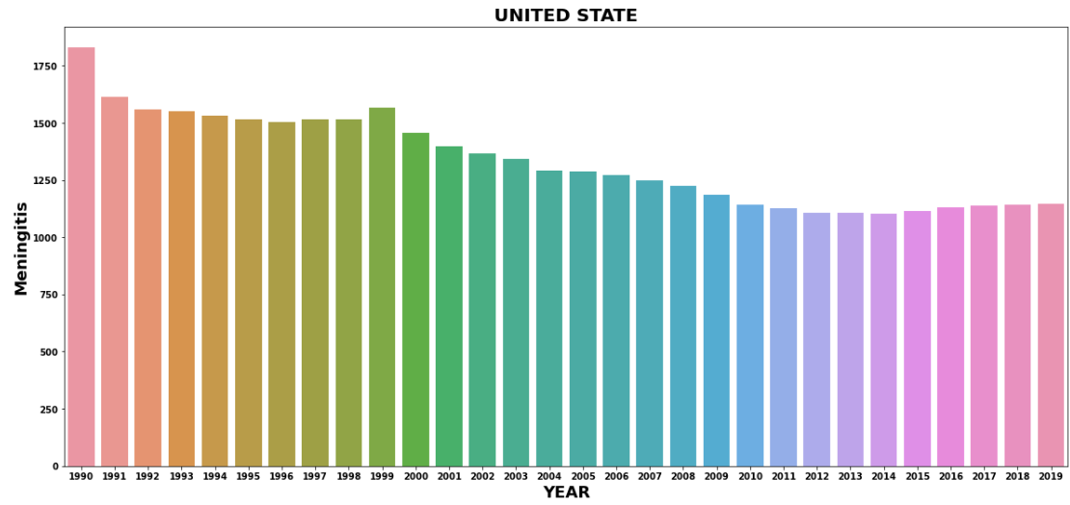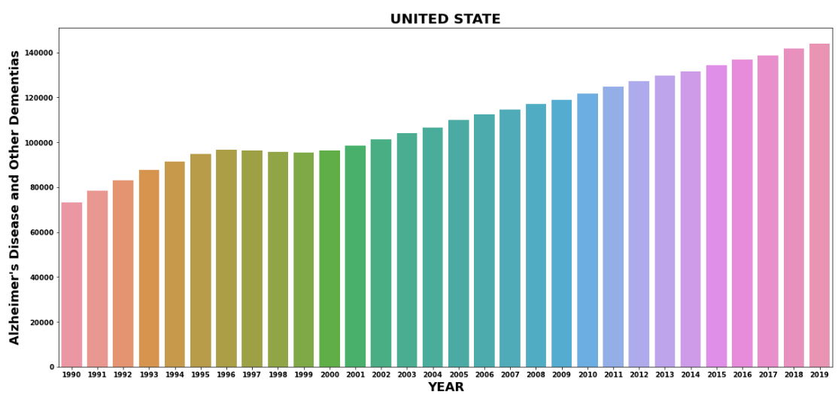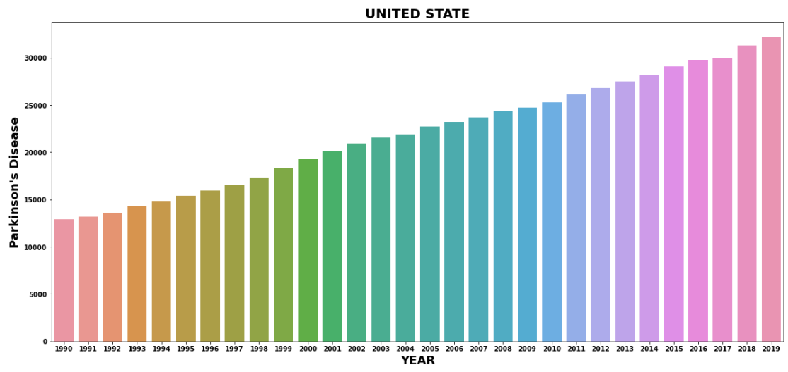

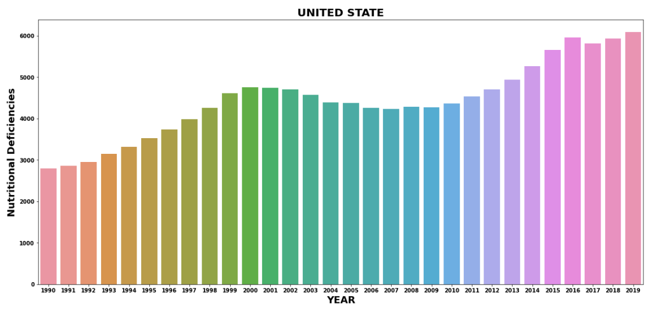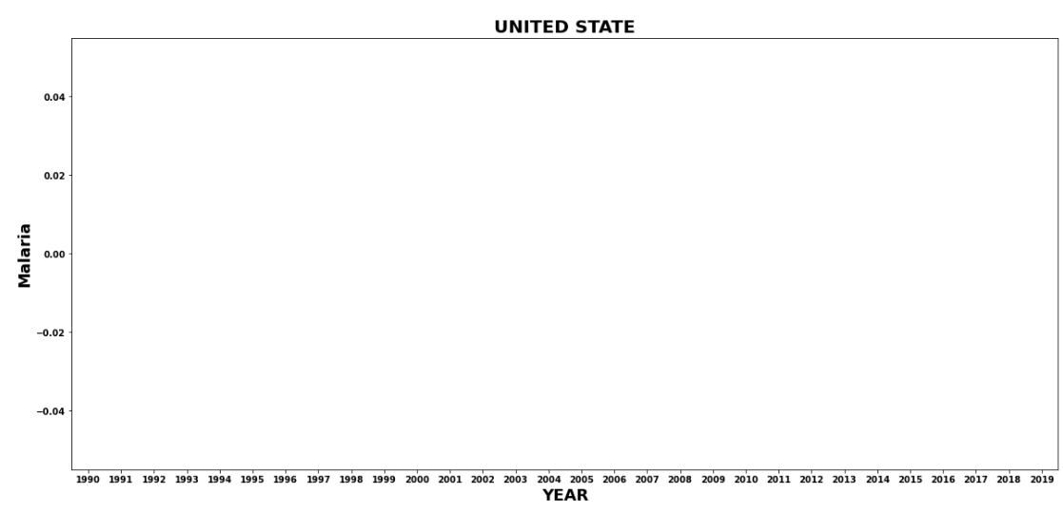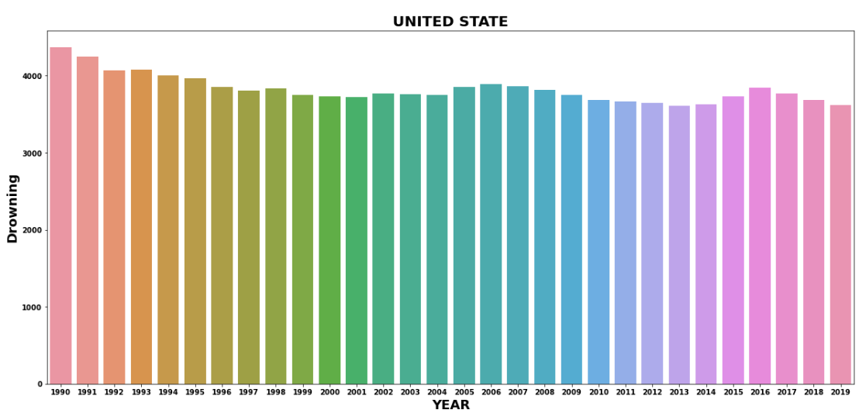

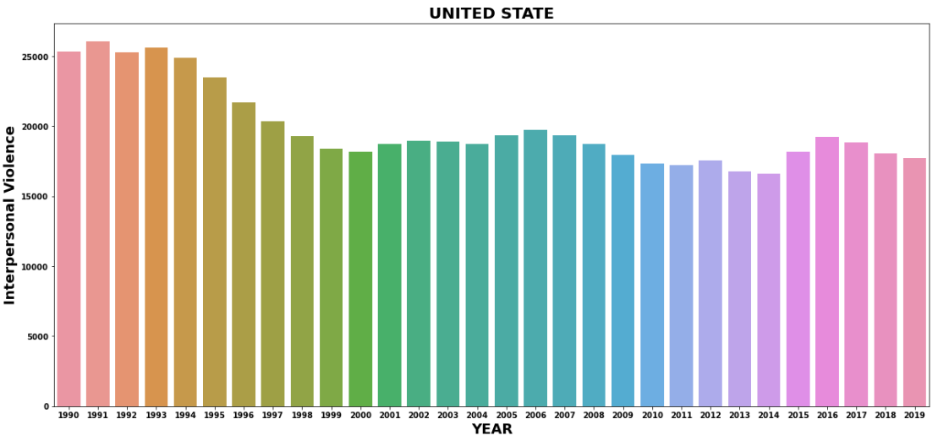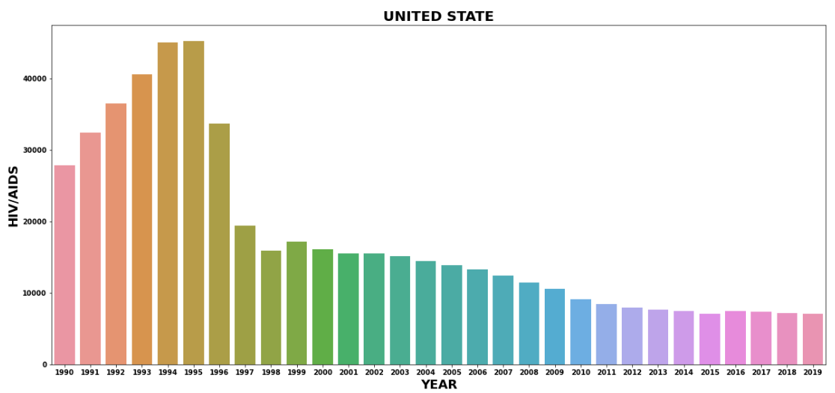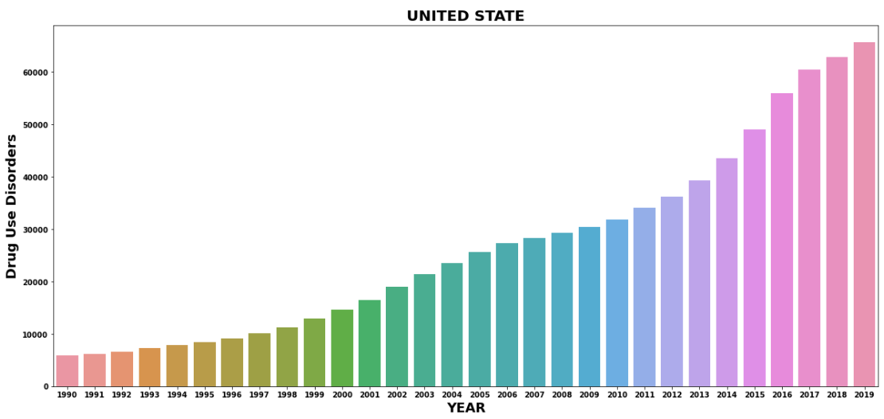

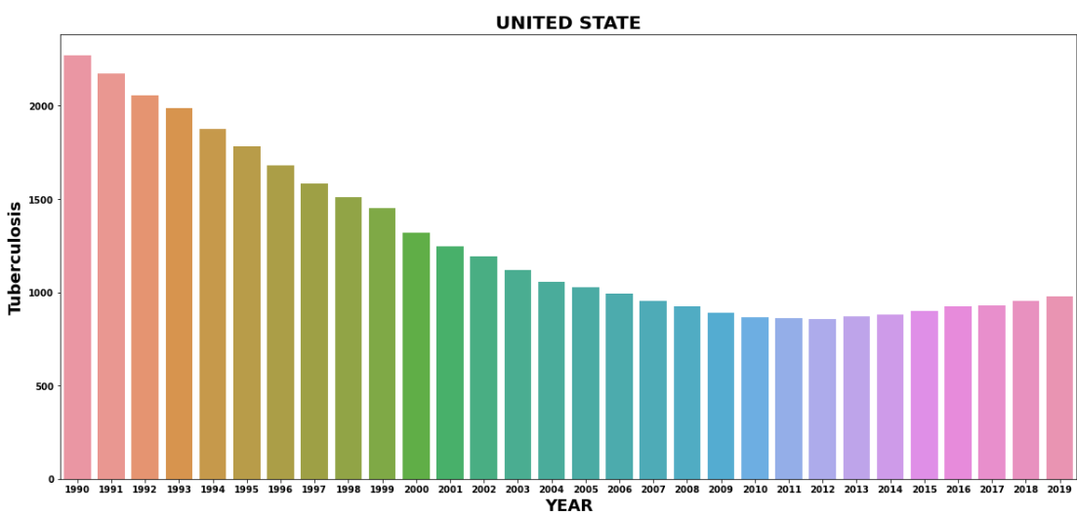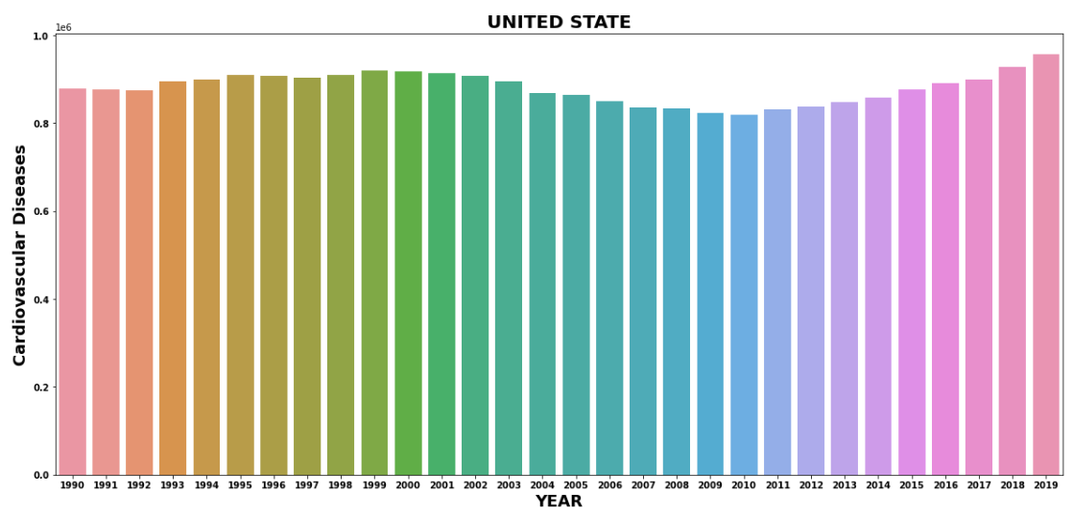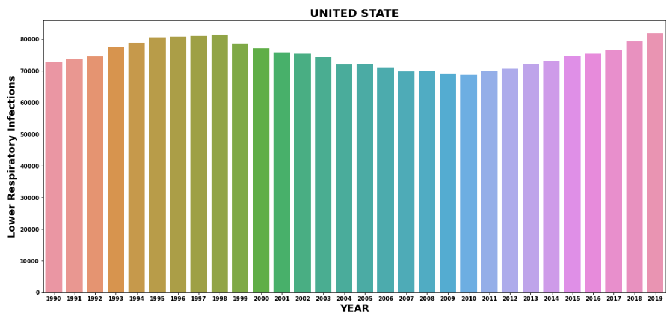

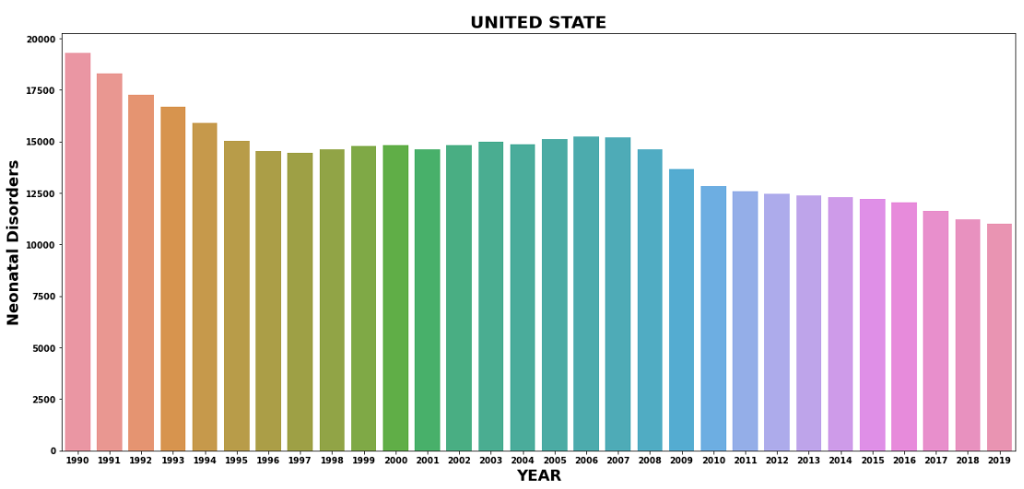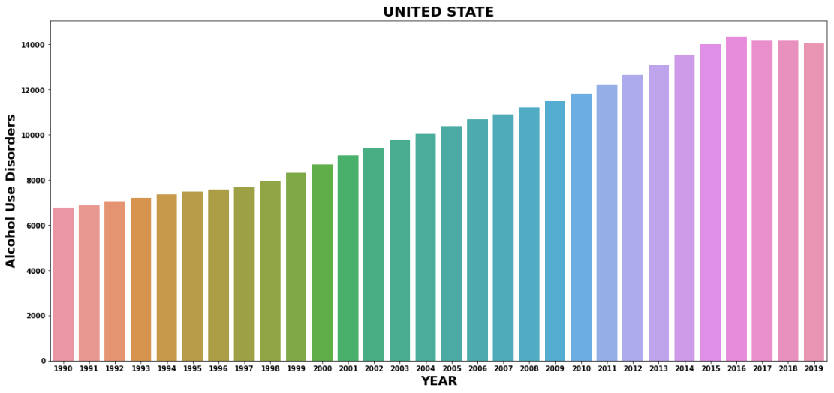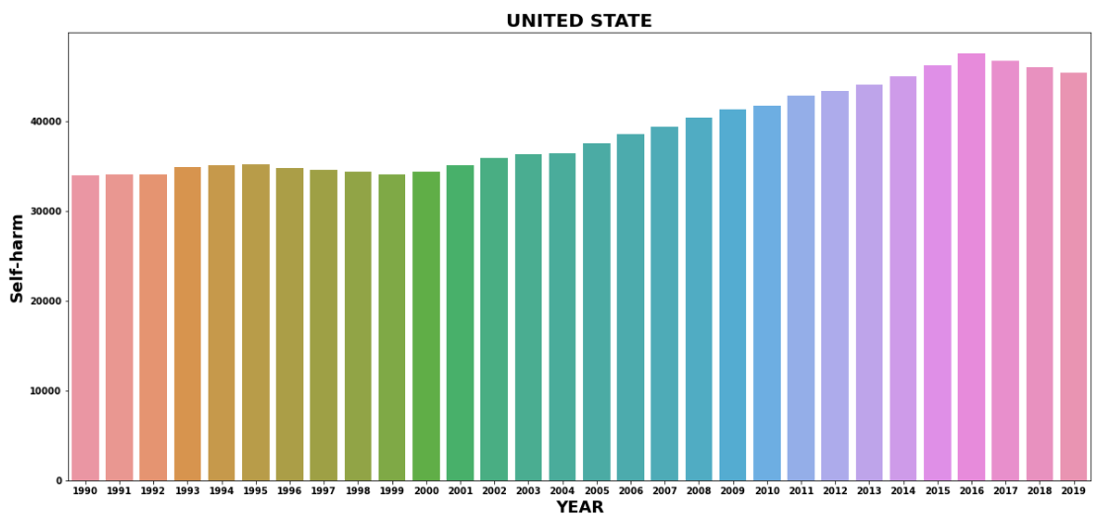

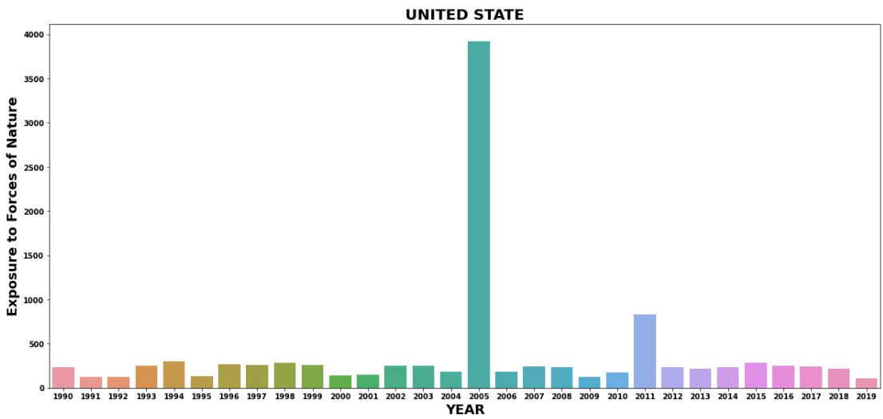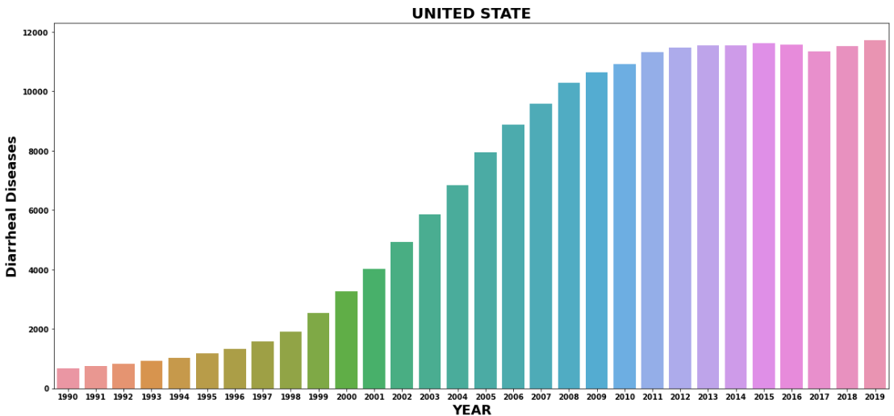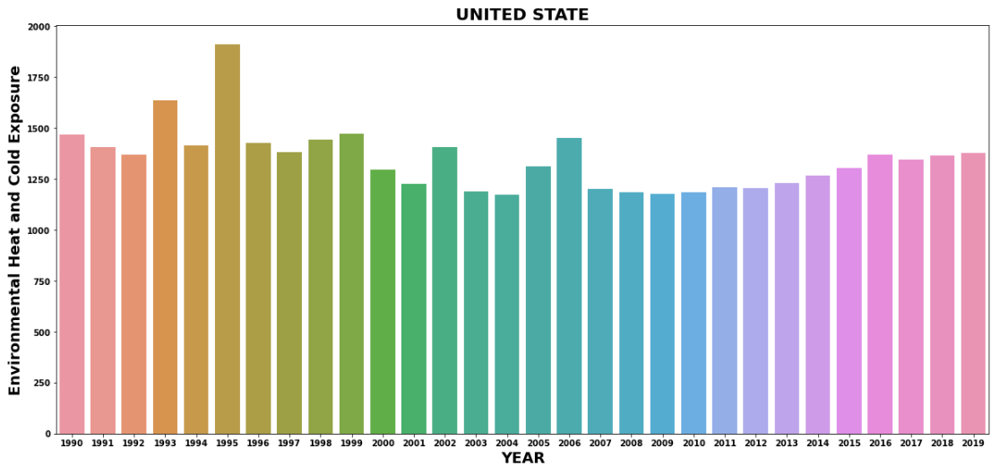

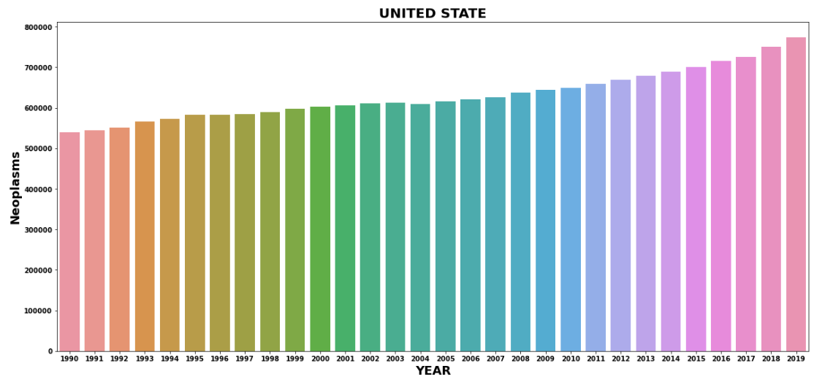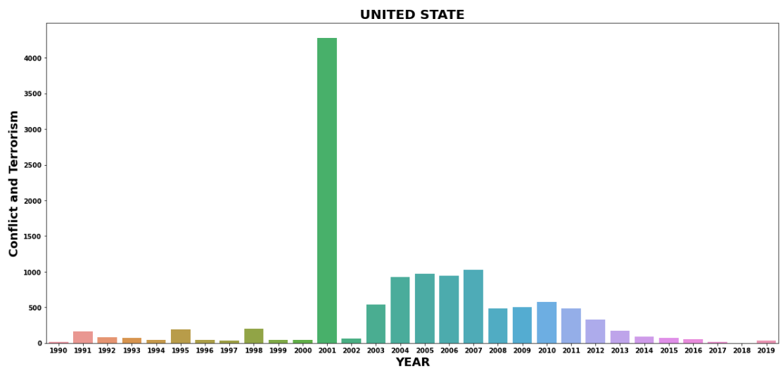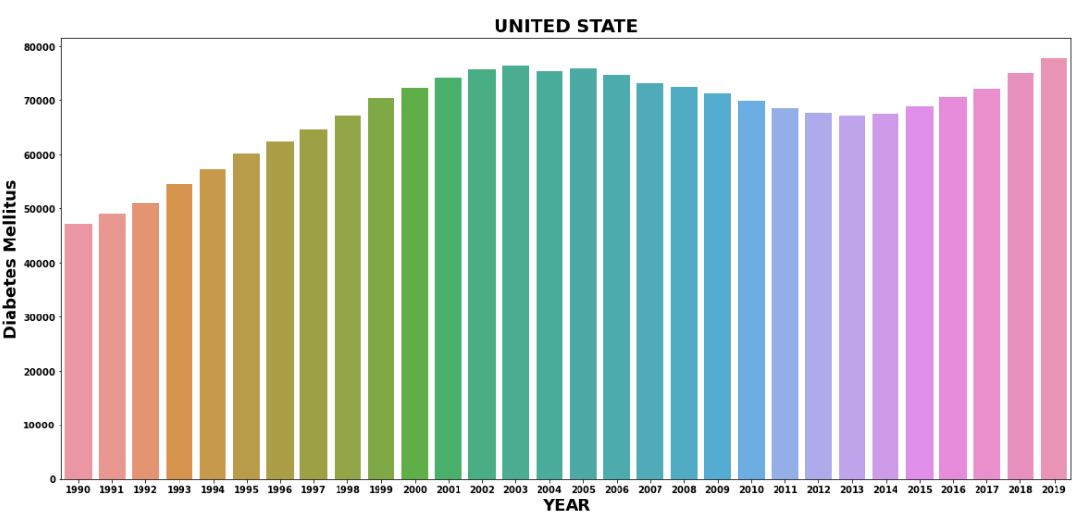

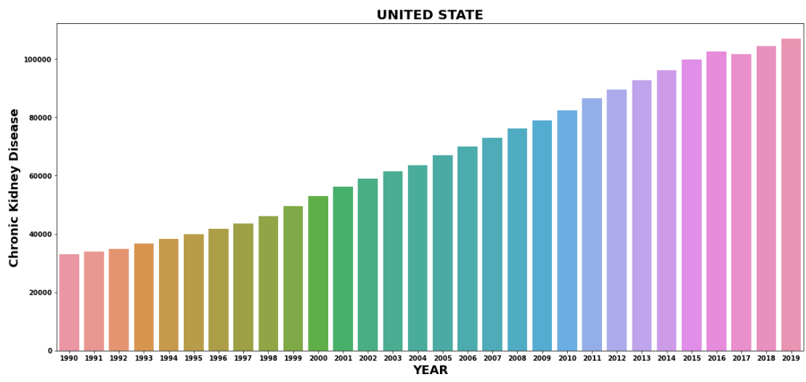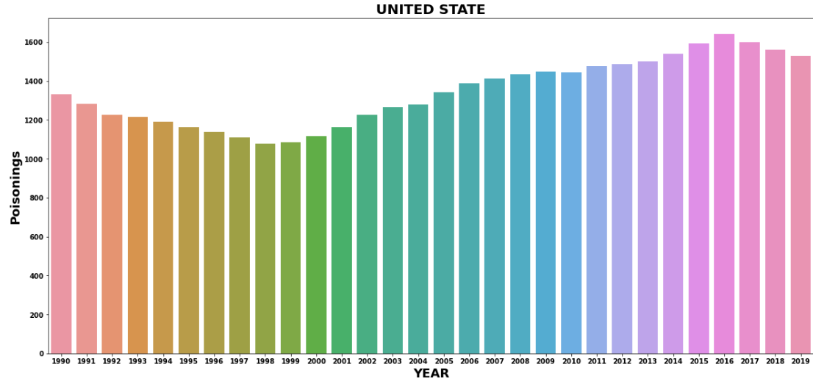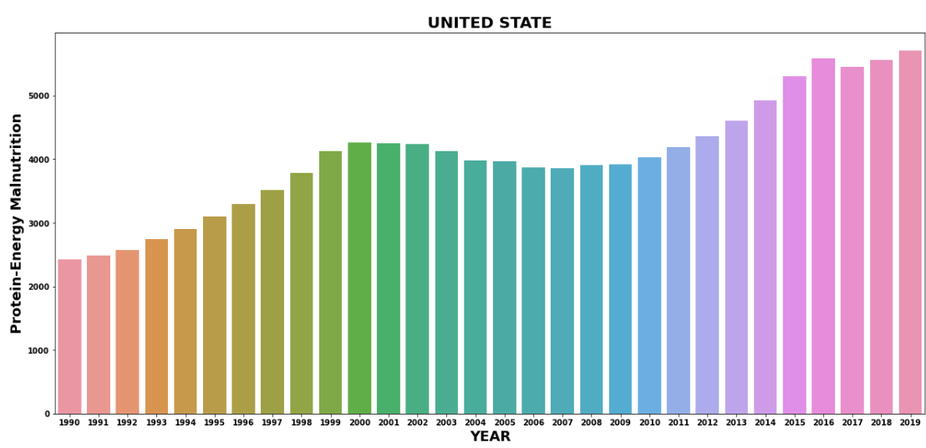

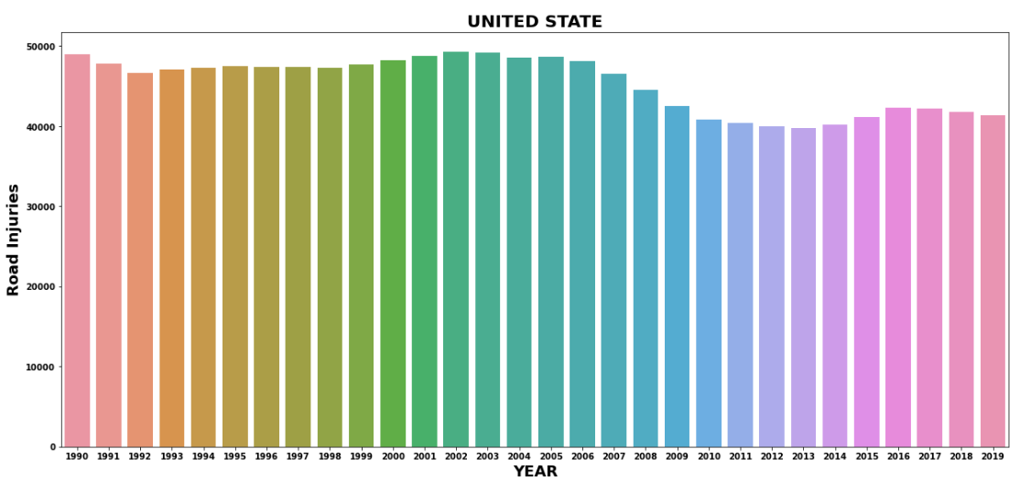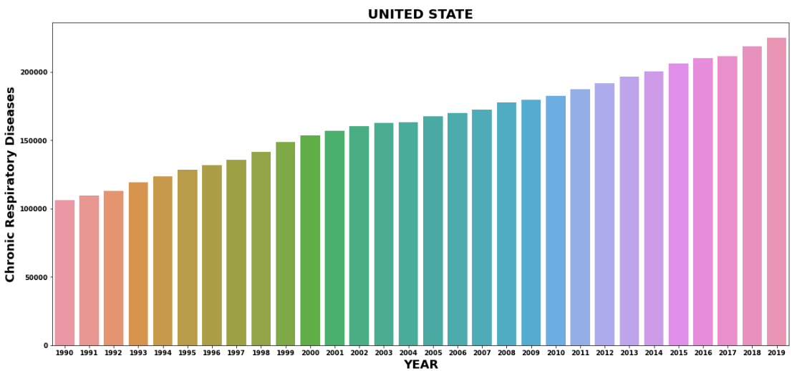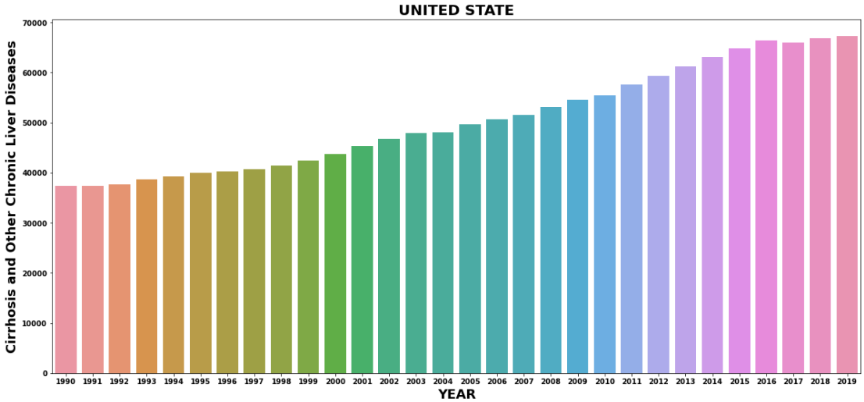

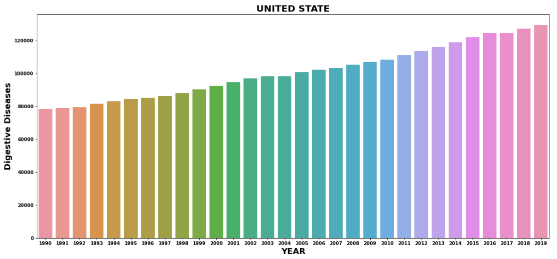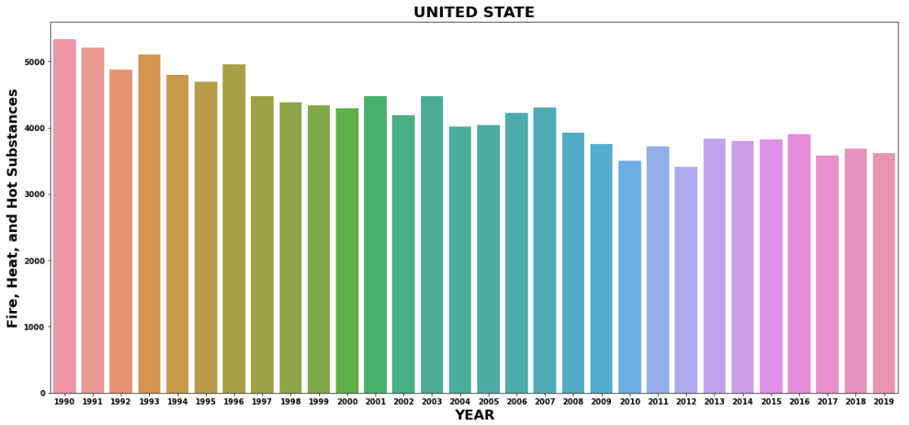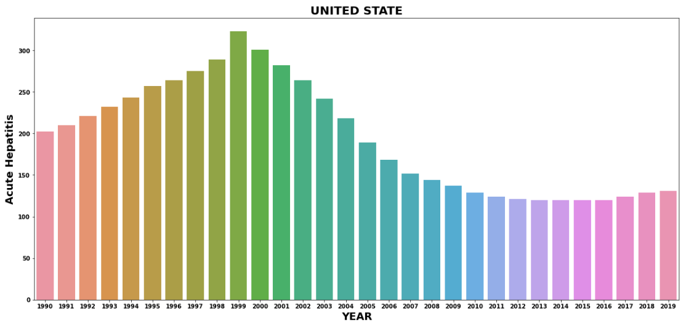

**OBSERVATION:-**

**\* THE DEATH FROM THE MENINGITIS IN USA IS**

**SLOWLY DECREASES YEAR BY YEAR**

**\* THE DEATH FROM THE ALZHEIMER'S DISEASE**

**OTHER DEMENTIAS IS INCREASES YEAR BY YEAR**

**\* THE DEATH FROM THE PARKINSON'S DISEASE**

**IS INCREASES YEAR BY YEAR**

**\* THE DEATH FROM THE NUTRITIONAL**

**DEFICIENCIES IS INCREASES IN 2001 AND THEN DECREASES TILL 2009 ANT THEN INCREASES**

**\* THE DEATH FROM THE MALARIA IS ZERO**

**\* THE DEATH FROM THE DROWNING IS NOT**

**INCREASES AND NOT DECREASES**

**\* THE DEATH FROM THE INTERPERSONAL**

**VIOLENCE RAPIDELY DECREASES FROM 1990**

**TO 2000 BUT AFTER 2000 SHOW CONSTANT**

**\* THE DEATH FORM THE MATERNAL DISORDERS IS INCREASES YEAR BY YEAR**

**\* THE DEATH FROM THE HIV/AIDS IS FIRST**

**INCREASES AND THE DECREASES FORM 1997**

**\* THE DEATH FROM THE DRUGS USE DISORDERS INCREASES YEAR BY YEAR**

**\* THE DEATH FROM THE TUBERCULOSIS IS**

**DECREASES FROM 1990 TO 2008 AND THEN SHOW CONSTANT GRAPH**

**\* THE DEATH FRIM THE CARDIOVASCULAR**

**DISEASES SHOW CONSTANT GROWTH IN GRAPH**

**\* THE DEATH FROM THE LOWER RESPIRATORY**

**INFECTION SHOW ALMOST NO CHANGE**

**\* THE DEATH FROM THE NEONATAL DISORDER**

**SHOW SLOWELY DECREASE**

**\* THE DEATH FROM THE ALCOHOL USE**

**DISORDER SHOW INCREASES YEAR BY YEAR**

**\* THE DEATH FROM THE SELF-HARM INCREASES YEAR BY YEAR**

**\* THE DEATH FROM THE EXPOSURE to Forces of Nature is increases in 2005 and 2011**

**\* the death from the Diarrhea Diseases increases**

**Rapidly year by year**

**\* the death from the Environmental Heat and Cold Exposure show constant line in graph**

**\* the death from the Neoplasms show increases year by year**

**\* the death from the Conflict and Terrorism show drastic increases in 2001**

**\* the death from the Diabetes Mellitus increases**

**slowly**

**\* the death from the Chronic Kidney Disease**

**increases year by year**

**\* the death from the Poisonings increases slowly**

**year by year**

**\* the death from the Protein-Energy Malnutrition**

**increases year by year**

**\* the death form the Road Injuries show constant**

**line graph**

**\* the death from the Chronic Respiratory Diseases**

**increases year by year**

**\* the death from the Cirrhosis and Other Chronic**

**Liver Diseases increases year by year**

**\* the death from the Digestive Diseases year by year**

**\* the death from the Fire, Heat, and Hot**

**Substances slowly decreases year by year**

**\* the death from the Acute Hepatitis slowly**

**decreases but from 2003 rapidly decreases**

# **lets examine death in India USA and china from 1990 to 2019:-**

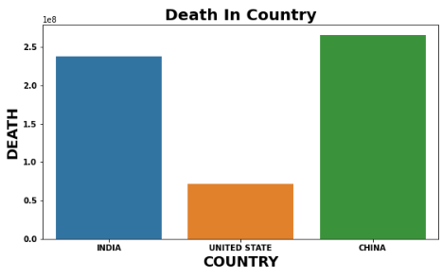

**OBSERVATION:-**

* **AS WE SEEN IN THE GRAPH OVEROLL CHINA**

**AND INDIA HAS HIGHEST NUMBER OF DEATH**

**THEN UNITED STATE**

**THANK YOU**

**THE END**